Building back better

Organic agriculture for smallholder farmers in Northern Cambodia

SAVING

LIVES

CHANGING LIVES

7^-

Cambodian Agriculture  
Cooperative Corporation Plc  
'v. Piorworwig Public Private Producer PortnprWup -

C/AFSP

ir*e global agriculture & food secuity program

In partnership with

With funding from

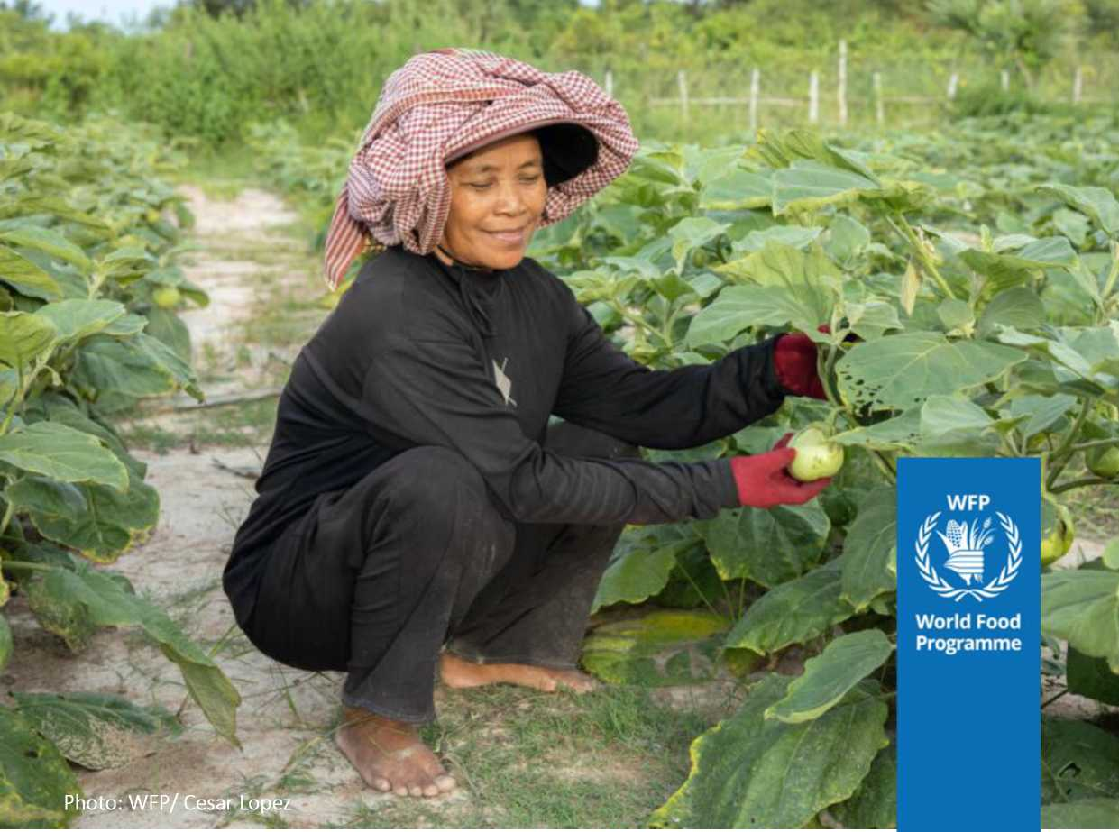

Contents

**Contents ii**

Abbreviations and acronyms iv

1. **Project overview 1**

Project summary 1

The challenge 1

The solution 2

Sectoral and institutional context 3

National policies 4

Relevant operations 4

Rationale 5

Strategic Approach 5

Key project features 6

Maps of the project area 7

1. **Project design and implementation strategy 8**

Project area 8

Target group 9

Development objectives and impact indicators 9

Outcomes 10

Outputs and activities 10

Output 1.1 10

Output 1.2 11

Output 2.1 12

Output 2.2 13

Timeline and community engagement 14

Detailed project theory of change 15

Risk identification and mitigation 17

Sustainability 18

Stakeholder engagement 19

Role of Agricultural Cooperatives 19

Governance, Oversight and Coordination 20

Oversight 20

Supervision 21

Procurement and Financial Management 21

Flow of funds 21

Reporting 22

1. **Monitoring and Evaluation (M&E) 22**

M&E framework 22

Monitoring Approach 22

1. **Budget 23**

Budget narrative 24

Outcome 1 24

Outcome 2 24

Project management and coordination 24

M&E and studies 25

1. **Building on best practices 26**

Smallholders as shareholders 26

Rural women’s economic empowerment 26

NOURISH: Improving Nutrition in Cambodia During the First 1,000 Days 27

Social and Behavior Change Communication Capacity Assessment 27

1. **Project timeline 29**
2. **Risk register 31**
3. **Detailed M&E framework 34**
4. **Detailed budget breakdown** Error! Bookmark not defined.

**Figures**

1. Theory of Change 9
2. Detailed Theory of Change 15
3. Stakeholders 18

**Tables**

Table 1: Budget summary 22

Abbreviations and acronyms

|  |  |
| --- | --- |
| AC | Agricultural Cooperative[1] |
| AIMS | Accelerating Inclusive Markets for Smallholders |
| AO | Area Office (WFP) |
| ASPIRE | Agricultural Services Programme for Innovation, Resilience and Extension |
| ARDB | Agriculture and Rural Development Bank |
| CACC | Cambodian Agriculture Cooperative Cooperation Plc. |
| CARD | Council for Agricultural and Rural De­velopment |
| CO | Country Office (WFP) |
| CRF | Corporate Results Framework |
| CSA | Climate-Smart Agriculture |
| CSDGs | Cambodian Sustainable Develop­ment Goals |
| CSO | Civil Society Organization |
| CSP | Country Strategic Plan (WFP) |
| FAO | Food and Agriculture Organization |
| FCS | Food Consumption Score |
| FFL | Fair For Life Certification |
| FGD | Focus Group Discussion |
| FIES | Food Insecurity Experience Scale |
| FMA | Field Monitoring Assistant |
| FNG | Fill the Nutrient Gap Analysis |
| FSN | Food Security and Nutrition |
| FSS | Food Systems Summit |
| GaM | Gender and Age Marker |
| GI | Geographical Identification |
| HA | Hectare |
| HQ | Headquarters (WFP) |
| IAP | Innovation Against Poverty |
| ICS | Internal Control System |
| IFAD | International Fund for Agricultural Development |
| IYCF | Infant and Young Child Feeding |
| JPRWEE | Joint Programme on Women’s Eco­nomic Empowerment |

|  |  |
| --- | --- |
| KAP | Knowledge, Attitude and Practice |
|  | (survey) |
| KII | Key Informant Interview |
| LoU | Letter of Understanding |
| M&E | Monitoring & Evaluation |
| MAFF | Ministry of Agriculture, Forestry and |
|  | Fisheries |
| MDD-C | Minimum Dietary Diversity-Children |
| MDD-W | Minimum Dietary Diversity-Woman |
| NGO | Non-governmental Organization |
| NSFSN | National Strategy for Food Security |
|  | and Nutrition (2019-2023) |
| P4 | Public-Private-Producer Partnership |
| PLW | Pregnant and Lactating Women |
| PMUAC | Preah Vihear Meanchey Union of Ag- |
|  | ricultural Cooperative |
| PS | Private Sector |
| RBB | Regional Bureau Bangkok (WFP) |
| RGC | Royal Government of Cambodia |
| SBCC | Social and Behaviour Change Com- |
|  | munication |
| SBN | Scaling Up Nutrition Business Net- |
|  | work |
| SEIA | UN COVID-19 Socio-Economic Impact |
|  | Assessment |
| SLA | Sustainable Livelihoods Approach |
| SUN | Scaling Up Nutrition |
| VHSG | Village Health Support Groups |
| WB | World Bank |
| WFP | World Food Programme |
| WHO | World Health Organization |

The term AC will be in the present project docu­ment to align with the local context.

1. Project overview

Building back better: Organic agriculture for smallholder farmers in

**Project Title**

Northern Cambodia

|  |  |
| --- | --- |
| **Geographical coverage** | Koh Nhek district, Mondulkiri Province, Kingdom of Cambodia |
| **Supervising entity** | United Nations World Food Programme (WFP) |
| **Lead Agricultural Cooperative** | Cambodian Agriculture Cooperative Corporation (CACC) |
| **Project implementors** | WFP and CACC |
| **Duration of project** | 4 years: October 2022 - September 20262 |
| **Total project financing** | 2,890,000 USD  *of which:*   * 1,790,000 USD is funded by the Global Agriculture and Food Se­   curity Program (GAFSP) for project activities   * 1,100,000 USD is co-financed by CACC. |

Project summary

1. Building back better from the COVID-19 pandemic calls for courage, creativity and flexibility in pro­gramme design. Any project must begin from the premise of sustainable and equitable growth, while remaining attuned to multiple economic, nutritional, societal and environmental needs and concerns. Piloting this layered and context-sensitive approach, Cambodian Agriculture Cooperative Corporation is partnering with the World Food Programme on a project in Mondulkiri province to support and enhance smallholders’ engagement in organic agriculture, thereby creating the basis for inclusive and sustainable economic growth, while enhancing nutritional outcomes.

The challenge

1. Mondulkiri is one of Cambodia’s most deprived provinces, lagging far behind the rest of Cambodia on socio-economic and gender equity indicators and recording one of the country’s highest malnutri­tion rates.[2] [3] Mondulkiri borders Vietnam, which has significant relative competitive advantages in ag­ricultural production. Good infrastructure, low-cost logistics, better access to energy and affordable financing allows Vietnam to operate at a lower cost, resulting in lower prices and advantages in mass production and marketing.
2. Poorly equipped to adapt and lacking adequate infrastructure, smallholder farmers in Mondulkiri province are also particularly vulnerable to shocks. The COVID-19 pandemic has reversed the previous trend decelerating agricultural expansion. Over 225,200 migrant workers (including 102,000 women) have returned from abroad due to reduced work opportunities and restrictive measures in host coun­tries. Between June and October 2020, the number of smallholder farmers increased by 184 percent.[4] Meanwhile the income generated from farming declined. By October 2020, the average household was earning USD 72 per month from farming activities, compared to USD 124 per month in June 2020.5,6
3. Exclusion from food value chains risks leaving many of Cambodia’s smallholder farmers behind. Women are especially susceptible to the effects of shocks, with fewer alternative options to make a livelihood, whether measured in terms of economic resources, employment options or available cop­ing mechanisms. While women make up just over half of the agricultural labor force and produce an estimated 70 percent of the country’s food, they account for only 24 percent of household agricultural holding managers, 12 percent of agricultural extension officers and 10 percent of agricultural exten­sion services beneficiaries. This disparity is exacerbated in Mondulkiri Province. The limited support for women farmers combined with the limited access to secondary education places severe re­strictions on women’s agricultural production.
4. The damage to the economy and individual livelihoods caused by the COVID-19 pandemic further threatens access to healthy diets and may be further exacerbated by the current food and fuel crisis. Deteriorating economic circumstances force people to purchase less nutritious food and increase their intake of rice, further compromising household nutrition. In 2017, the WFP *Fill the Nutrient Gap* study found that 66 percent of households in Mondulkiri could not afford the least expensive adequate, nutritious diet. Many more households did not consume a nutritious diet due to a lack of know-how.[5] [6] [7] In these households, children are at higher risk of chronic malnutrition, which in turn increases the risk of death from infectious diseases and reduces school performance. Parents in households with inadequate diets experience a decreased income earning capacity caused by a lower productivity.
5. Consultations with local stakeholders (women Agricultural Cooperative (AC) members and Village Health Support Group (VHGS) members) underlined the widespread prevalence of gender inequality.[8] Considering the additional economic stress caused by COVID-19, sexual and gender-based violence (GBV) is of particular concern as, globally, there has been a significant increase in the prevalence hereof.[9] On average, two cases are reported monthly in each of the villages covered by the project - in all probability, a significant under-reporting since reporting only occurs when the couple is consid­ering a divorce or in cases with severe bodily harm.[10]

The solution

1. The project contributes to a sustainable, people-centered recovery from the COVID-19 pandemic through a joint venture with smallholder farmers in Koh Nhek district, Mondulkiri Province, empow­ering them as shareholders in the organic agriculture value chain. The project will combine innovative interventions with the twin goals of livelihood promotion and enhanced individual nutrition. Accord­ingly, the project is built on two integrated components: (i) developing an inclusive and profitable organic value chain; and (ii) enhancing nutritional outcomes.
2. The first component aims to boost smallholders’ income and business skills by incentivizing them to switch to an increasingly profitable organic farming model relying on a growing market and sup­ported by an integrated value chain. The global market for organic food, estimated at USD 92 billion in 2017, grew further during the start of pandemic, and has since grown further in response to height­ened consumer demands for safe and healthy food.[11] Prices of organic commodities are higher and more stable than traditional commodities, creating opportunities for higher profit margins and stead­ier sources of income.
3. The second component aims to enhance nutritional outcomes in the targeted areas to support long­term recovery from the pandemic. Social and behavior change communication (SBCC), with selected tailored communications approaches, activities, and tools will be used to positively influence behav­iors targeting key nutritional determinants as well as gender equality in the household.
4. The two components are complementary and mutually reinforcing. The holistic food systems de­sign is central to building back better, as it promotes resilience by eradicating weaknesses in current agricultural practices, while a shift towards organic production and increased processing safeguard against future uncertainty through increased income generation. The institutional focus on empow­ering of women facilitates a structural change, with anticipated spill-over effects in the private sphere, where women currently carry most of the workload. Nutrition education and SBCC will support future capacity development through increased production efficiency and learning potential.
5. The project will build on established joint-venture models. The project will strengthen the value chain through the development of necessary infrastructure (i.e., storage facilities) and build on local partnerships to maximise efficiency. The establishment of infrastructure will enable AC members to better manage seasonal supply fluctuations, reduce post-harvest losses (currently standing at 13 per­cent nationally[12]), and help maintain a stable and better price. Infrastructure will also reduce the risk of aflatoxins, which are regularly found in improperly stored staple commodities, thereby linking to the project’s nutritional component, as aflatoxins are known to interfere with the absorption of vita­mins and minerals, negatively impacting nutritional status.[13]
6. Collectively, these improvements will feed back into the livelihood asset base of targeted house­holds, enhancing their human, financial, physical, natural, and social capital, ultimately contributing to building back better and more sustainable livelihoods, resilient to the negative impact of the pan­demic and other shocks.

Sectoral and institutional context

1. Agriculture and agro-industries are the main economic activities in Mondulkiri. Due to limited knowledge of market trends and demands, smallholder farmers tend to restrict their cultivation to rice, employing largely traditional methods. Yields and quality are vulnerable to climatic shocks. Inter­nal control systems and traceability are limited. Limited know-how and inadequate post-harvest in­frastructure constrain engagement in more profitable agricultural practices. Additionally, there are few options to access credit at low interest rates. Consequently, the current private sector engage­ment for value-addition extension services, such as drying and milling, are limited, severely constrain­ing income generation. With high debt levels and limited financial know-how, particularly amongst women, smallholders are left highly vulnerable to economic and climatic shocks.
2. While the Royal Government of Cambodia has made targeted efforts in recent years to redress gender imbalances, women entrepreneurs still mostly remain in the informal sector and face addi­tional challenges in the business environment. A low level of financial education, limited capacity in business planning, and a lack of information about formalization procedures and tax incentives, are compounded by a limited time for networking and partnerships due to their double responsibility as entrepreneurs and primary caretaker within the household. Women’s disadvantages are further ex­acerbated by social norms, according to which business is viewed an activity reserved for men.

National policies

1. The development of an inclusive and equitable agricultural value chain is a key priority for the Government of Cambodia. The food security and nutrition sector is guided by the second **National Strategy for Food Security and Nutrition** (2019-2023) (NSFSN) and the Government’s Action Plan for the Zero Hunger Challenge. The NSFSN outlines diversified and sustainable food production, nutrition­sensitive food value chains and food environments as essential to the Cambodian food system. The NSFSN highlights eight main activities as priorities for the development of a nutrition-sensitive food value chain in Cambodia.
2. **Cambodia’s Roadmap for Food Systems for Sustainable Development 2030** highlights healthy diets for all and empowerment of youth, women and the vulnerable as its first two priorities. Climate change is included as an overarching challenge to food systems development, with reference to the need to reduce the use of chemicals and pesticides and for promoting organic farming. Meanwhile private sector engagement was highlighted across thematic areas.
3. One of the key aspects of both the second NSFSN and Cambodia’s Roadmap for Food Systems for Sustainable Development 2030 relates to the use of social and behavior change communication (SBCC). Generally, government decisiveness and commitment to strengthening the use of SBCC as a tool for enhanced nutrition outcomes is high. The Ministry of Health has recently issued its **national SBCC strategy for nutrition** targeting the first 1,000 days. The government and development partners have made significant efforts to integrate SBCC in nutrition programmes as a key strategy for achieving health and nutrition outcomes.
4. The crucial role of women in promoting environmental stability and engaging in the production processes in agriculture, forestry and fisheries have been recognized and integrated into national ag­ricultural policies and strategies. The **Gender Mainstreaming Policy and Strategic Framework in Ag­riculture, 2016-2020 and the Gender Mainstreaming Action Plan in Agriculture, 2016-2020** were endorsed in alignment with the government’s Rectangular Strategy IV and the National Strategic De­velopment Plan (NSDP).

Relevant operations

1. The project takes into consideration relevant, ongoing operations and will seek convergence with these as appropriate. These include:
2. Two IFAD-funded projects, the Agricultural Services Programme for Innovation, Resilience and Ex­tension (ASPIRE) and Accelerating Inclusive Markets for Smallholders (AIMS), provide complementa­rity by strengthening support to smallholder farmers for the commercialization of agricultural pro­duce. The ASPIRE project focuses on improving extension services that will help smallholder farmers contribute to broad-based economic growth and achieve profitable and resilient farm businesses through evidence-based policy development; capacity development for extension services; improved access to extension services; and infrastructure to support climate-resilient agriculture. The AIMS pro­ject focuses on value chain development through brokering, facilitation, innovative development, and capacity-building support to inclusive growth of five higher-value product value chains, namely rice, silk, chicken, cassava, and vegetables, as well as value chain financing.
3. The National Nutrition Programme (NNP), the Ministry of Health’s flagship nutrition programme, is dedicated to reducing maternal, infant and child mortality by improving the nutritional status of women and young children. VHGS play an important role in NNP’s work on nutrition awareness raising and for referrals to health facilities. They are also responsible for reporting to the health centers. Con­sultations with VHSG members in the target district illustrate a lack of training on the behaviors which will be targeted by this project. UNICEF supported training of VHSG members. The UN Nutrition coordination platform will be leveraged to ensure the project builds on these and other ongoing/up- coming trainings.[14]
4. Development and Partnership in Action (DPA), a Cambodian non-government organization (NGO), has had significant interventions in the target district, focusing on building the capacity of community leaders in the areas of gender equality, natural resource management, health, and education. Alt­hough DPA’s interventions are drawing to a close, they were referenced very positively in the commu- nities,[15] for which reason a knowledge exchange on best practices for community engagement will be sought. Additionally, the implementation strategy draws on the latest evidence and assessments avail­able, including smallholders as shareholders, rural women’s economic empowerment, the Nourish project, and a social and behaviour change communication capacity assessment. See **Annex 1** for a detailed description.

Rationale

1. Cambodia has been establishing a position in international food markets as a producer of high- value organic goods, with a growing market share in both Europe and the USA. With a view to more equitable distribution of the benefits of this growing industry, the project will aim to maximize reach and inclusiveness, with particular attention paid to excluded and disadvantaged groups, particularly women and indigenous people. The project will focus primarily on the production of organic rice and secondarily on organic cassava and organic cashew nuts, thus allowing CACC’s existing export network to be leveraged to maximize sales in the short and medium term.
2. In terms of the impact on human capital development, a focus on nutrition is equally essential to supporting long-term recovery from the pandemic. Prior to the pandemic, the WHO classified both stunting (32 percent[16]) and wasting (10 percent) rates in Cambodia as very high. The damage caused by the pandemic to the economy and individual livelihoods threatens access to healthy diets. Eco­nomic circumstances have forced people to adopt increasingly drastic coping mechanisms, further compromising household nutrition. A range of overlapping, interlinked and intergenerational deter­minants contribute to poor child growth and stunting, with dietary intake and morbidity are amongst the immediate, primary drivers. They are for this reason central to any approach to building back bet­ter.

Strategic Approach

1. The strategic priority of CACC and constituent members (ACs) is to synergize the efforts of the private sector, producers, and the public sector towards a common goal of improving the country’s agricultural production, enabling a better business environment, while enhancing the livelihoods of smallholder farmers. This strategy relies on commitments of all stakeholders towards building a relia­ble value chain, while ensuring that smallholder farmers are enabled to deliver quality products, traded at premium prices.
2. Another essential condition of sustainable success is a gender-sensitive approach. Taking into ac­count social conditions and traditional gender roles in Cambodian society, the project will engage trusted community structures such as the Commune Councils and VHSGs. The use of these channels to secure real change has been validated through Focus Group Discussions (FGDs).[17] A rigorousmonitoring and evaluation system will be established and managed by WFP with a view to strength­ening the institutional capacity of CACC to fully manage this aspect of the project. Project partners and government will be engaged to ensure the project is well positioned to inform future institutional development and policy dialogue, with a view to supporting future scalability. The project will work through existing private sector and government systems to avoid duplication and ensure sustainabil­ity.

Key project features

|  |  |
| --- | --- |
| **Target groups** | 6 to 8 Agricultural Cooperatives (AC) composed of 1,200 to 1,600 smallholders (55% women) and 6,000 - 8,000 AC family members (80% women, 50% indigenous peoples) via social and behaviour change communication (SBCC). |
| **Contextual Focus** | Despite the gradual improvements in economic growth and poverty reduction in recent years, many smallholder farmers in Cambodia continue to live close to the poverty line. The eco­nomic impacts of the COVID-19 pandemic caused many of the most vulnerable Cambodians, often employed in the country’s large agricultural sector, to slide back into poverty. The con­flict in Ukraine and impacts on fuel and food costs are straining household purchasing power and may lead to a further deterioration in food security and nutrition. Malnutrition rates among children under five are already high, with 22% stunted and 10% wasted. The 2017 *Fill the Nutrient Gap study* found that 66% of households in Mondulkiri were unable to afford a nutritious diet. The 2014 *Cost of Malnutrition study* estimated that 400 million USD were lost in 2013 due to the double burden of malnutrition, equivalent to 2.5% of GDP. |
| **Programme impact and outcome** | **Impact:** Smallholder farmers, especially women and indigenous peoples in Koh Nhek district, Mondulkiri province will have improved income and enhanced food security and nutrition.  **Outcome 1**: Improved and more resilient livelihoods of smallholder farmers built through strengthened agricultural value chain and integration of smallholder farmers, increased productivity, organic certifications, and marketing of products.  **Outcome 2.** Women and adolescent girls’ empowerment enable improved nutritional diver­sity and reduced stunting among girls and boys under the age of five in the context of a changing climate. |
| **Outputs and activities** | **Output 1.1**. ACs are used as platforms to transform smallholder farmers into agro-entre- preneurs.   * **Activity 1:** Skills development * **Activity 2:** Financial and digital literacy   **Output 1.2.** Smallholder farmers transition into organic farming and are increasingly inte­grated into the value chain.   * **Activity 3:** Establishment of infrastructure and access to credit * **Activity 4:** Last mile and organic certification * **Activity 5:** Brand and marketing strategy for organic products from Mondul­   kiri  **Output 2.1.** SBCC strategy implemented to increase and improve knowledge, attitudes, and practices related to gender and nutrition.   * **Activity 6:** Development of a tailored SBCC Strategy and materials * **Activbity 7:** SBCC nutrition sessions * **Activity 8:** Gender dialogue clubs   **Output 2.2.** Project results are used to strengthen institutional development and capacity.   * **Activity 9:** Yearly outcome monitoring and analysis * **Activity 10:** Studies * **Activity 11:** Workshops on P4 |

|  |  |
| --- | --- |
| **Key partners** | Members and representatives from Agricultural Cooperatives; representatives from all levels of the Ministry of Health (MoH), the Ministry of Women’s Affairs (MoWA), the Ministry of En­vironment (MoE) and the Ministry of Agriculture, Forestry, and Fisheries (MAFF); central level representatives from the Ministry of Interior (MoI), Ministry of Commerce (MoC), the Ministry of Rural Development (MoRD) and the Council for Agricultural and Rural Development (CARD). |

Maps of the project area

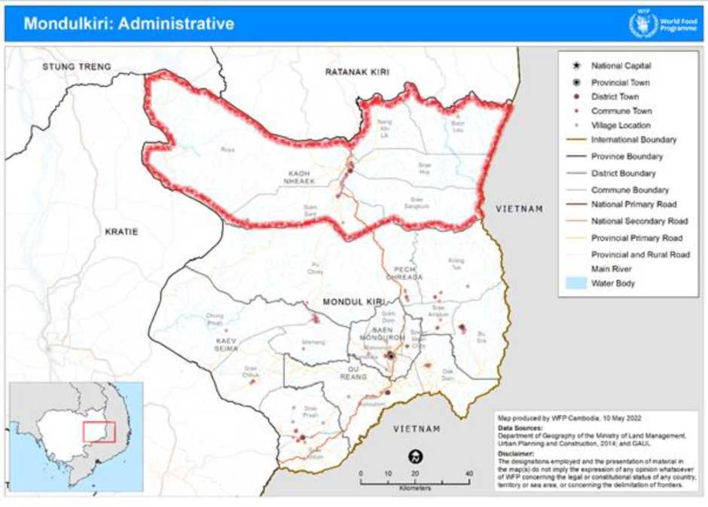

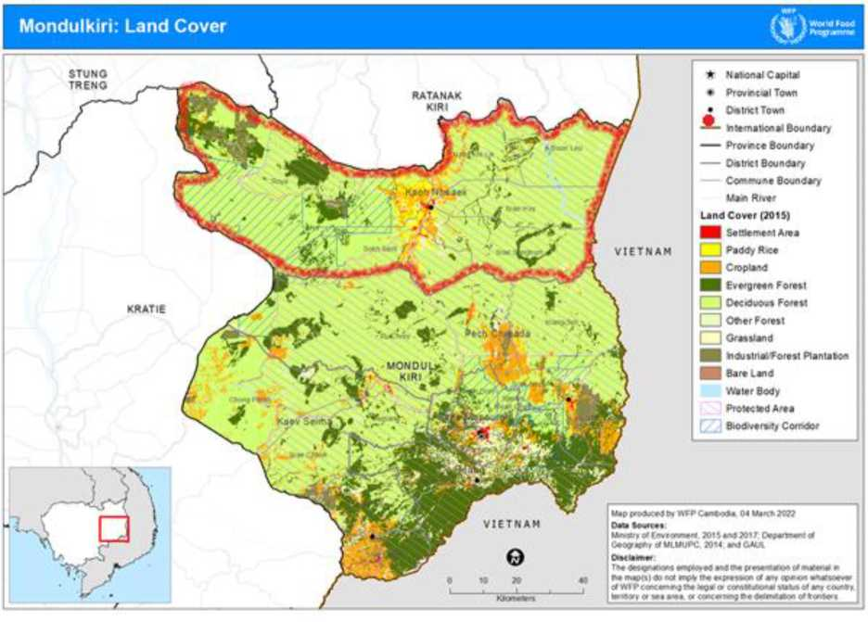

2. Project design and implementation strategy

Project area

1. The project will target one district (Koh Nhek) in Mondulkiri province, which houses the majority of arable land in Mondulkiri.[18] Located in the remote north-eastern plateau ecological zone, the ele­vation of this province varies from 40 to 1,030 meters above sea level, with the highest altitudes in the southeast and the lower level (flood plain) in the west and north[19]. Mondulkiri has two distinct seasons: a rainy season from May to October and a dry season from November to April. The average annual total rainfall was about 1,800 millimetres (mm) over the period 1991-2020.[20]The hottest tem­perature is observed in April, the month before the rainy season starts, with average maximum tem­perature of 33°C, whereas cooler temperatures are recorded as low as 19°C in January.[21] [22] [23]
2. The mountainous topography, remoteness, and low population density (5 persons/km2),22,23of Mondulkiri create logistical challenges. With limited market access, increased transportation costs are a disincentive to commercial production, intensified by the small scale of land parcels and absence of collective political representation of smallholder farmers, which weakens bargaining power and makes them less attractive to potential buyers. Despite these challenges, the Ministry of Agriculture, Forestry and Fisheries is advising farmers in Mondulkiri to explore its favourable land and climate to diversify crops and encourage farmers to grow more crops to meet consumer needs.[24]

Target group

1. Primary beneficiaries include the five ACs registered with the Ministry of Agriculture, Forestry and Fisheries in Koh Nhek district, Mondulkiri. The 5 ACs have 461 members, 71 percent of whom are women. Youth (under 35 years old) represent 40 percent of the total farmers, while indigenous peo­ples represent 37 percent. The project will seek to increase the representation of indigenous peoples to 50 percent by the project’s end.
2. The project will work with existing ACs[25] and incentivize additional members to join and/or form new ACs. The project will have a final target of between six to eight ACs with a total of 1,200 to 1,600 smallholder farmers as members, of which at least 55 percent should be women. Newly formed ACs will be provided support to register and offered participation in the CACC joint venture on equal terms with existing ACs. The ACs will be gradually integrated in the project over the project period to stagger the activities and integrate lessons learnt in each phase.
3. The project will target smallholder farmers and their extended families and communities through SBCC approaches, reaching between 6,000 and 8,000 people (80 percent women). Women will be targeted based on their inclusion in agricultural practices through the AC and on their nutritional vul­nerability, with priority for pregnant women, women of reproductive age, and households with chil­dren under two years and/or adolescent girls.
4. Secondary beneficiaries of the programme include husbands, fathers, parents-in-law, health cen­tre personnel and VHSGs. Agricultural extension workers will also be included in the project as they will support the facilitation of trainings in organic agriculture and accordingly will be trained before­hand.

Development objectives and impact indicators

1. Aligned with the GAFSP theory of change, the project’s (simplified) theory of change (Figure 1) establishes two overarching project goals: i) improved income and ii) enhanced food security and nu­trition of smallholder farmer households, thereby contributing to SDG1 “End Poverty”, SDG2 “Zero Hunger” and SDG5 “Gender Equality’’. The two project goals were selected as a means to promote a sustainable recovery from the negative impacts of COVID-19.

Figure 1. Theory of change

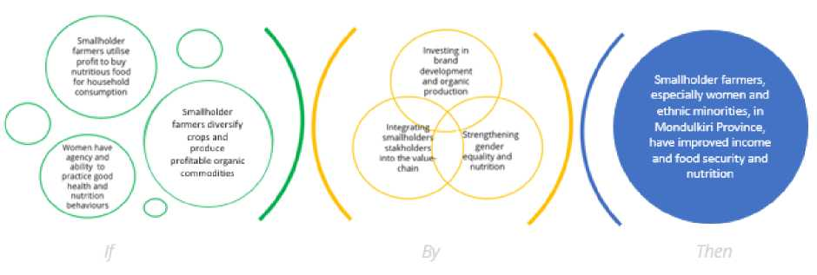

Outcomes

1. The project will contribute to the overall goals via two outcomes associated with a twin-track ap­proach as outlined below.

*Outcome 1:* Improved and more resilient livelihoods of smallholder farmers built through strength­ened agricultural value chain and integration of smallholder farmers, and increased productivity, or­ganic certifications, and marketing of products.

*Outcome 2:* Women and adolescent girls’ empowerment enable improved nutritional diversity and re­duced stunting among girls and boys under the age of five in the context of a changing climate.

A detailed theory of change is provided on page 15.

Outputs and activities

Output 1.1.: Agricultural cooperatives are used as platforms to transform smallholder farm­ers into agro-entrepreneurs

*Activity 1: Skills Development*

1. To address the risk-adverse behaviour of smallholder farmers and gradually strengthen small­holder farmers’ farming and business capacities, the project will provide a series of trainings to ACs and smallholder farmers. The trainings will focus on:

* Theory and practice of organic farming;
* Crop diversification;
* Production inputs, incl. linkages to organic input producers
* Techniques to increase agricultural yields;
* Production, preparation and use of organic fertilizers;
* Quality assurance and internal control systems;
* Agricultural best practices including climate-smart methods;
* The organic certification process; and
* Hygiene.

1. The training content and delivery methods will reflect best practices and be tailored to the local context to enhance accessibility and effective learning and draw on findings from studies conducted under activity 10 (Studies). The curriculum will be developed, translated to Khmer and delivered by a contracted technical organization (specialized NGOs and/or companies) with support from CACC and accredited extension workers in close coordination with the relevant government institutions at all levels. An emphasis will be placed using the training session to raise awareness on the importance of including women in decision-making processes as well as business operations, thereby linking to ac­tivity 8 (Gender dialogue clubs). The project will seek to engage local civil society organizations (CSOs) to enhance their skills and capacities to take on a strengthened role in increasing gender-responsive agricultural systems at the community level.
2. Because the switch to organic farming requires a strong commitment, in addition to the acquisition of new skills, advocacy and consultations among AC members will be undertaken to support the adop­tion of new approaches. Awareness sessions on the benefits of the organic farming model will also be provided to local leaders, who will also be heavily engaged in all assessments and trainings. The project will focus on the continued production of rice, which is Cambodia’s largest food export, and small­holder’s primary cash-crop. This will support the transition towards organic production by operating in a space where the smallholder farmers feel confident. To support intercropping and soil-develop­ment, a secondary focus will be on organic cashew nuts and organic cassava[26], which are also relatively well-known in the target area.

*Activity 2: Financial and digital literacy*

1. Trainings on financial and digital literacy will support the development of business acumen of AC members, with AC representatives also receiving specific business courses on management and en­trepreneurship to support their understanding.
2. A training of trainer’s package will be developed (and/or adjusted from existing approaches, as appropriate), using a participatory methodology. The training of trainer’s package will be comprised of courses on motivational speaking as well as learning workshops. Masterclasses on basic manage­ment skills will seek to actively equip AC representatives with tools and knowledge for business model design, implementation and negotiation, and develop entrepreneurial skills to promote the replication with their members. A cascade training model will be applied.
3. To ensure meaningful engagement of women, the trainers will engage leading male stakeholders to act as advocates to sensitize, champion and support gender equality and women’s inclusion in the AC governance structures. This will link with activity 1 (skills development) and activity 8 (gender dia­logue clubs).

Output 1.2.: Smallholder farmers transition into organic farming and increase their income per hectare.

*Activity 3: Establishment of infrastructure*

1. CACC will build a warehouse in a strategic location in Mondulkiri to form the backbone of the organic value chain and location to consolidate, store, dry, mill and package the produce of the par­ticipating ACs and their respective members. CACC will complement this investment by the establish­ment of a drying and milling facility to enhance post-harvest handling. Smallholder farmers utilizing the facilities will pay a minimal storage fee to CACC which will be responsible for the operation, maintenance, and insurance of the warehouse. When feasible, local workforce and materials will be used in the construction to create income-generating opportunities in the community. The warehouse and processing facilities will also be available for ACs from neighbouring provinces where the pro­cessing capacity allows.
2. In partnership with the government-owned Agriculture and Rural Development Bank (ARDB), CACC will facilitate low interest loans to smallholder farmers who stock their produce at the ware­house, an approach successfully implemented with CACC’s warehouse in Preah Vihear province. The warehouse receipts system will connect individual collection bags to cooperatives, and farmers and smallholders will be able to use their produce as collateral to obtain credit from ARDB and micro­finance institutes (MFIs) with which CACC has established partnerships. This will be closely linked with activity 8 (Gender dialogue clubs) to ensure sensitization on the role of women entrepreneurs. Fur­thermore, participating farmers will also be matched with local businesses, which produce organic inputs to support the promotion of organic farming.

*Activity 4: Last mile and organic certification*

1. The project will provide support to the organic certification process targeting CACC’s existing mar­kets (EU and US). The comprehensive support will include the following activities:

* Establishment of an internal control system;
* Support to record management;
* Pre-audit assessments and internal audits;
* External audits and support for the audit process; and
* Support to address and solve potential non-conformity.

1. The organic certification will build the foundation for other certification types such as Fair for Life (FFL) demonstrating that the products are socially responsible, inclusive and support the conservation of all living things. The certification/registration as Geographical Identification (GI) will also be ex­plored to enhance the reputation of the agricultural produce in line with the efforts under activity 5 (brand development and marketing).
2. The project will establish a traceability system (last mile) as part of the value chain to ensure com­pliance with standards for organic production. The result of every activity in the system will be rec­orded and made available for the next user in the supply chain, resulting in complete transparency. The system will focus on fast clearance by reducing duplication of data capture and will enable instant referencing of previous steps in the supply chain. The project will also work closely with government to undertake the needed spot-checks. Any identified gaps will be used to inform the continued training under activities 1 (Skills development) and 2 (Financial and digital literacy).

*Activity 5: Brand and marketing strategy for organic products from Mondulkiri*

1. To enhance market prospects, the activity will aim to create a brand for organic commodities from the highlands of Mondulkiri province. For the Mondulkiri organic brand to be successful, the added value must be perceptible and valued by the consumer. To support ACs in strengthening marketing around organic products, the project will firstly focus on mapping out the added value perception. This will be done in close collaboration with Cambodian-based business and trade associations such as EuroCham Cambodia.[27]
2. A comprehensive desk review will be completed to establish a framework for collecting the needed data on the knowledge, attitudes, and practices of potential consumers in the EU and US. Business associations and trade organization will be invited to review and validate these through inclusive FGDs and key informant interviews (KII). This step is essential to shaping a business case and developing appropriate messages to inform the development of a communication strategy. An important compo­nent of the strategy will be audience segmentation and dissemination channels and frequency, focus­ing on how this links to or differentiates from CACC’s existing buyer’s network.
3. To build on best practices on brand development and marketing globally, the Scaling up Nutrition Business Network (SBN) will support south-south knowledge exchanges, facilitate connections to val­idate the certifications and their applicability in different markets and establish linkages to relevant business associations.

Output 2.1.: SBCC strategy implemented to increase and improve knowledge, attitudes, and practices related to gender and nutrition

*Activity 6: Development of a tailored SBCC Strategy and materials*

1. Targeting the same beneficiaries identified under outcome 1, the programme will focus on adapt­ing the national SBCC strategy to the local context and support the rollout for a sustainable and co­herent approach. Men and influential community members will be included in the process in consid­eration of their role as gatekeepers for behaviour change.
2. Demand generation will comprise one component of the SBCC strategy, focusing on increasing awareness and generating a demand for healthy diets among pregnant and lactating women, adoles­cents and children aged 6 - 23 months; increasing demand for family planning and pregnancy services; and increasing positive, healthy behaviors for diarrhea, acute malnutrition, and immunization.
3. With mobile phone ownership in Cambodia near universal,[28] the national SBCC strategy has iden­tified digital media and the target population as a critical platform for engaging target audiences under the national SBCC for nutrition strategy.[29] Accordingly, digital communication will comprise a second component of the SBCC strategy. After nearly two years of COVID-19-related travel restrictions and bans on gatherings, the Ministry of Health is increasingly investing in online training methodologies and the development of applications to share information. The project will leverage these tools as applicable.
4. Based on the SBCC Strategy, a community-mobilization manual (along with respective materials) on Training of Trainers for interpersonal communication will be developed. With support from a media partner, the project will prepare an interactive methodology and develop content for varied audiences in which diverse actors (beneficiaries, VHSG members, agriculture extension agents, and tradi- tional/religious leaders) will share success stories to motivate uptake of services and targeted behav­iors.

*Activity 7: SBCC nutrition sessions*

1. Based on the materials established under activity 6 (SBCC strategy), a detailed plan for delivery of weekly interpersonal SBCC sessions will be developed. The sessions will be delivered by VHSGs with the support of a specialized NGO using a range of tools and techniques, including real-life examples, role play, cooking demonstrations and community debates. It will also involve activities with local and digital media targeting a broader audience. A minimum of eight sessions will be facilitated for each of the behaviours identified. Participation in the sessions will include the household couple as well as adolescents and be held at a convenient time.

*Activity 8: Gender dialogue clubs*

1. Gender dialogue clubs will be established to create momentum towards gender equality and women’s empowerment. There will be one session per week for a minimum of 16 weeks. A compre­hensive desk review on gender roles and FGDs with the target population found that gender-based violence, decision making, roles and responsibilities in the household and women as business owners were critical issues to address for women’s empowerment. The topics covered will be structured ac­cordingly. Additional topics may be identified based findings from activity 10 (studies). Membership in the dialogue clubs will include the household couple and be held at a convenient time. This activity will be facilitated by the same cooperating partner supporting activity 7 (SBCC nutrition sessions) and ideally include a community leader or other local authority figure.

Output 2.2.: Project results are used to strengthen institutional development and capacity *Activity 9: Annual outcome monitoring and analysis*

1. Project assessments will be regularly conducted as part of the M&E system described in section 3. Based on monitoring documented findings, course corrections will be implemented during the pro­gramme life cycle. In line with WFP’s corporate evaluation policy, the entire country portfolio, includ­ing this intervention, will be subjected to a thorough evaluation. WFP will also conduct a dedicated mid-term review of this programme to inform adjustments.

*Activity 10: Studies*

1. Two different studies will be conducted at the onset of the project: i) a knowledge, attitude, and practices survey, and; ii) a district-specific gender analysis.[30] The knowledge, attitude, and practice survey will focus on dietary behaviours, sexual and reproductive health, childhood diseases, and gen­der. The survey will set the baseline for SBCC interventions and identify what is known, felt, and done related to the behaviours the project aims to influence. The gender analysis will assess gender dy­namics related to the project and to inform gender dialogue clubs (methodology, additional focus areas and material development). The studies will also inform programme strategies and training ma­terials under Outcome 1 as relevant and be used to set outcome targets and enable comparison and measurement of programme achievements.
2. A dedicated case study will also be carried out between year three and four on a topic to be jointly decided during workshops organized as part of activity 11 (Workshops on Public-Private-Producer partnerships).

*Activity 11*: *Workshops on Public-Private-Producer partnerships (P4)*

1. At all levels, the government has expressed significant interest in strengthening the integration of private sector for development objectives.[31] To facilitate understanding of how this may work better in practice, the project will arrange workshops to discuss key learnings. The workshops will bring together the private sector, AC and government representatives, civil society and other key stakehold­ers working across P4.
2. The objectives of the workshop(s) will be set in close consultation with all stakeholders, while adhering to the following overall outcomes:

* Strengthened awareness on the importance of P4;
* Strengthened technical capabilities on how to support ACs in their development;
* Strengthened awareness of relevant national policies;
* Strengthened public-private exchange and commitment to quality, production, and mon­

itoring; and

* Strengthened role of CSOs in the ACs.

1. The SBN will be leveraged as a platform to facilitate the workshops considering their mandate to strengthen public-private-producer relations.

Timeline and community engagement

1. The project will be implemented over four years, starting late-2022. Community mobilization and preparatory activities were crucial in the project design and will continue in the implementation stage. In close coordination with member ACs and government, the project will actively advocate for new members through community fairs[32] and consultations. To this end, the project has developed a de­tailed engagement plan.
2. This approach in accordance with accountability to affected populations, which will be ensured through various means. WFP has a dedicated staff to manage complaints and feedback channels, in­cluding a telephone hotline. The hotline numbers will be distributed across different activity sites and integrated to all project materials used in the field. WFP will also ensure that trainings for staff, part­ners, community, services providers, and other relevant stakeholders are conducted regularly to strengthen their capacity to interact with beneficiaries in a dignified, respectful, and coherent manner and report and follow-up on protection and gender-related issues. Compliance with the UN Secretary General’s Special Measures for Protection from Sexual Exploitation and Sexual Abuse will be manda­tory for all cooperating partners.
3. The complete timeline for engagement and activities may be found in **Annex 2.**

Detailed project theory of change

1. The project theory of change, outlined in Figure 2, details how the cohesive approach will integrate nutrition-sensitive and gender-transformative activities across agriculture, health, and economic de­velopment. The diagram includes how project activities, outputs and results are aligned with the five pillars of the GAFSP theory of change, namely: Pillar 1: Increased agricultural productivity; Pillar 2: Improved farmer to market linkages; Pillar 3: Reduced risk and vulnerability; Pillar 4: Improved non­farm rural livelihoods; and Pillar 5: Improved institutions.

Figure 2: Detailed project theory of change

t

PILLAR

ACs are trained in business and financial

MoH Nutrition SBCC strategy rolled out

ACs' production is increased and stable

New markets are added

ACs are better able to manage the seasonal supply fluctuations and reduce post-harvest loss

Risk of intergenerational malnutrition is reduced

Gender transformative dialogues are held with

ACs have enhanced skills and capacities build resilient and profitable food systems

Brand for Mondulkiri' organic products established

Profit from organic value chains are sustained

Income per ha is increased

Women practice good health and nutrition behaviours

Women and adolescent girls have increased awareness and knowledge on good nutrition practices

AC members, especially female, have enhanced access to high-quality inputs

AC members, including women, have increased access to finance and understanding of how to best apply credit

Interactive community

—► sensitization sessions are conducted

Agriculture Cooperatives are included in profitable organic rice, cassava and cashew nut value chains, increasing overall household income

Small holder farmers, especially women and indigenous people, in Mondulkiri Province have improved income and food security and nutrition ..

Smallholder farmers utilise profit to buy nutritious food for household

Small holder  
famers' resilience  
to climate shocks  
are increased

Soil quality is  
enhanced

ACs are trained in  
organic farming

ACs are certified in  
organic practices

Small holder farmers  
diversify crops and  
produce profitable  
commodities

ACs practices  
organic agricultural  
methods

MM

AC members have access to post­production value addition (storage, dry, mill, package)

Organic produce is marketed as high- quality

Consumption of  
improperly stored  
staple foods are  
decreased  
(minimizing risk of  
consuming aflatoxins)

ACs are trained in  
improved agricultural  
techniques

Traceability system  
established

Marketing Strategy  
developed

Women and adolescent girls in  
target communities have agencies  
over dietary habits, maternal, sexual  
and reproductive health, WASH  
practices and health seeking  
behaviours

Diverse actors in the community,  
especially men, community  
leaders and other influential  
community members, are  
sensitised in the importance of gender  
equality

Value chain  
infrastructure is built in  
strategic locations

Key  
messages are  
disseminated to  
target beneficiaries via  
interpersonal counselling  
and ITC

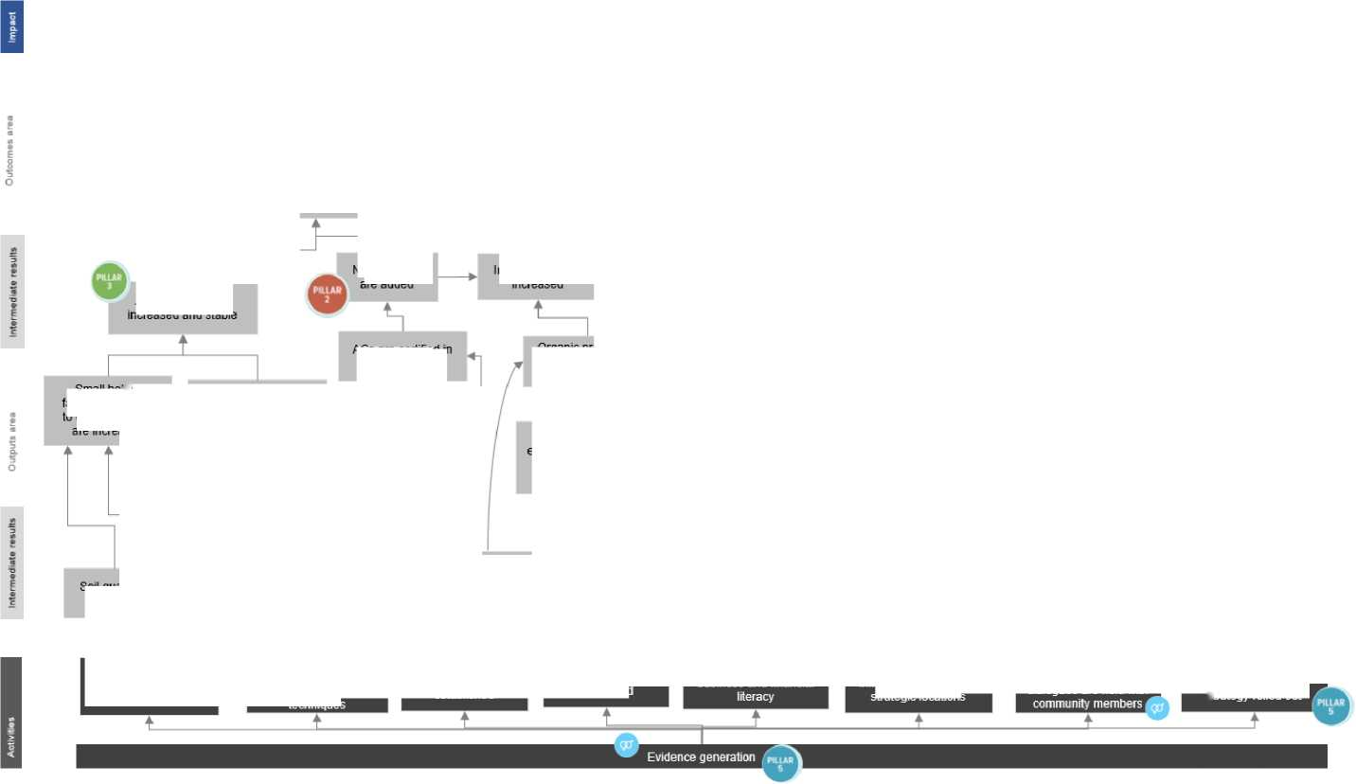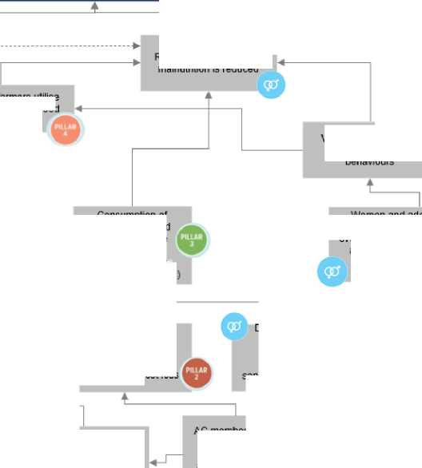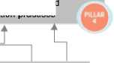

Risk identification and mitigation

1. The COVID-19 pandemic has had a significant negative economic impact on vulnerable populations in Cambodia, especially in rural areas, through income and employment shocks, global supply chain issues, and rising inflation, particularly for food and fuel. Frequent and prolonged movement re­strictions have led to considerable reductions in average household income. This is likely to be exac­erbated by the recent food crisis as increasing fuel prices have caused food price spikes. WFP will keep monitoring market prices and functionality throughout the country on a bi-weekly basis to ensure potential operational and programmatic risks are detected early on and addressed.
2. Due to the impact of climate change in Cambodia and the vulnerability of smallholders, the main technical risks are linked to the onset of climatic shocks, notably droughts. To mitigate this risk, the project will focus on the inclusion of appropriate and climate-smart irrigation systems during the tran­sitioning to organic farming. Efforts will also be made to monitor assessments related to climatic events which will be shared with farmers together with training on how to interpret this data. In that, WFP will draw on the national climate hazard monitoring platform (known as PRISM) operated by national and provincial disaster management committees with the technical support of WFP.
3. Another risk relates to limited uptake of organic farming practices by targeted smallholder farm­ers. The project will mitigate this risk through a strong community-based approach, starting with joint programme planning to inform the design of training modules. Accountability to the affected popula­tion will be a cross-cutting element in the programme, ensuring that target populations are consulted through means of their choice, provided with accessible information, and can provide feedback throughout the project cycle. Drop-out can be expected if targeted farmers are not able to meet the production standards for organic farming; to this end the project partners will ensure that there is robust capacity strengthening along the project cycle as well as strong process monitoring to identify and mitigate potential issues in a timely fashion.
4. With regards to the impact of the SBCC activities, the most considerable risk is related to the non­adoption of recommended behaviours. To ensure the strategy developed is context-relevant, the pro­ject design and implementation strategy places a strong emphasis on participatory and inclusive pro­grammes, which takes into consideration best practices and existing structures and programmes. To ensure full participation, this also includes bringing in traditional and religious leaders to give credibil­ity to the recommendations. Annual outcome monitoring will help monitor the adoption of knowledge, practices and behaviours communicated through the SBCC activities and enable mitigating actions where needed.
5. With respect to the institutional capacity needed for implementation, two main risks were identi­fied: the capacity of partners and the interest of government in facilitating the enabling environment. As mitigation, all third parties will be selected jointly by WFP and CACC, leveraging their different part­nerships, perspectives, and operational strengths. A strong emphasis will also be placed on joint plan­ning and coordination to ensure that stakeholders are kept updated and that implementation is taking place in line with the expected outputs and outcomes. A coordination structure involving the govern­ment at national, provincial, and local levels will support efforts linked to enhancing the enabling en­vironment as outlined in section 3.
6. Potential negative externalities include an increased carbon footprint through the shift towards an export-oriented model of agricultural production; accelerated deforestation in order to clear arable land; crowding out of agricultural production destined to meet local food needs as a result of increased organic cultivation destined for export; and increased incidents of gender-based violence due to the empowerment of women and disruption of existing social patterns. Mitigation measures include an approach to project planning and implementation that is participatory, inclusive and leverages local knowledge. Through the SBCC component WFP will also seek to raise awareness and transform this into knowledge and practices on gender equity and healthy eating habits with a view to boosting local demand for organic production methods.
7. A detailed risk register, which describes the risks, the likelihood and risk ratings - L (low), M (mod­erate), or H (high) - and proposed mitigation measures, is provided in **Annex 3**.

Sustainability

1. Sustainability of project outcomes is highly likely. Sustainability is a core project principle and has been factored into project design through the following design features and/or expected measures.

*Institutional sustainability*

1. At the ground level, project activities will be implemented primarily through ACs. The following steps have been planned to ensure that the key activities will continue to be performed by relevant groups in the post-implementation stage: i) a focus on cascade trainings to ensure the capacity stays within the organization upon project closure; ii) establishment of a strong M&E system to identify weaknesses and address them during the project implementation period; iii) workshops on P4 to strengthen engagement and position of ACs; and iv) alignment with national priorities and existing systems to avoid duplications, which may otherwise only operate during the project implementation period.

*Financial Sustainability*

1. No significant issue regarding financial sustainability arises since the project interventions (demon­strations, trainings, and capacity building) are one-time, non-recurring cost items. Once the farmers have been trained, these costs need not be incurred again. Integrating the private sector in the value chain will provide long-term incentives to smallholder famers to grow organically and create durable impact. Investments in the necessary infrastructure (i.e., warehouse) will upgrade the value chain for organic rice production and create long-term benefits for the local community. Maintenance and in­surance for the warehouse will be paid by CACC, which will charge a small storage fee from farmers utilizing the facility.

*Technical Sustainability*

1. The project will undertake the following activities to enhance technical sustainability: i) technical training provided to ACs with respect to financial and digital literacy; ii) technologies demonstrated to ACs will be relatively simple and will not necessarily generate a post-project demand for technical backstopping; and iii) technology dissemination at the ground level will be conducted by farmer-led mechanisms rather than external service providers.

*Social and Environmental Sustainability*

1. Socially, the project will target indigenous peoples and low-income women farmers, thus avoiding elite capture and maintaining broad support for the project at the ground level. It is widely recognized that organic farming is environmentally sustainable as it reduces the carbon footprint of conventional agriculture. Organic cultivation methods are conceived to improve locally available conditions through a holistic farming approach and by means of environmentally friendly techniques. They can render rainfed land more productive and resilient. Through enhanced soil fertility and biodiversity preserva­tion, harvests become more nutritious and sustainable. As organic cultivation methods significantly reduce the use of external inputs by refraining from chemosynthetic fertilizers and pesticides, farming becomes less capital-intensive and allows plants to develop natural pest and disease resistance. Long­term benefits include positive effects on human health and reduced negative impact on the environ­ment, particularly on biodiversity. Safeguard action plans will reduce tension and help manage any potentially negative social and environmental impacts. The M&E system will track social development indicators.

*Monitoring and Evaluation*

1. A strong monitoring system will assist in monitoring and assessing the sustainability of investments made under the project. Further details are elaborated in Section 3.

Stakeholder engagement

1. Several stakeholders at both national and sub-national levels will be engaged to inform the project design and ensure successful project implementation. The range and number of implementing agen­cies outlined in Figure 3 is determined by the nature of both the project and the institutional set-up in Cambodia.

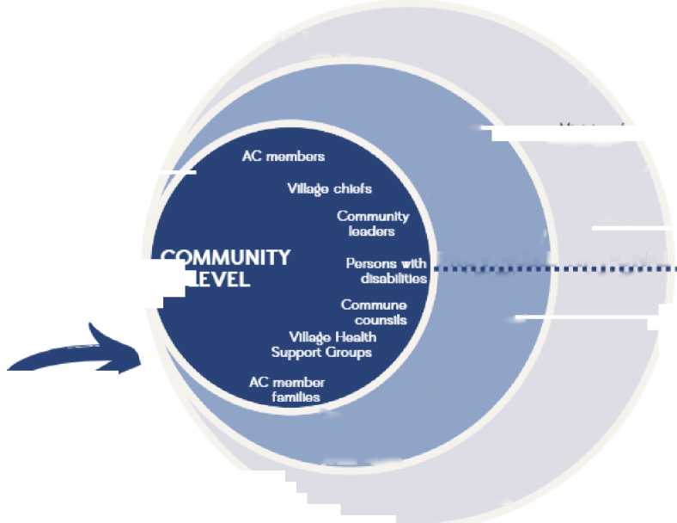Figure 3: Relevant stakeholders

**COMPONENT 1**

SUN Business Network

Ministry of

Interior Ministry of

Commerce

District office for

Agriculture and Environment

Ministry of Rural  
Development

Provincial department of Agriculture

Ministry of Envlornment

Provincial department of

Commerce

Ministry of Agriculture. Forestry and

Fisheries

**LEVEL**

LEVEL

District Office

**COMPONENT 2**

Provincial working group for FSN

Provincial

Department of Heallth

for Health.

Women and Social Affairs

Ministry of Women's

Ministry of

Heallth

Council for

Agriculture and

Rural Development

Affairs

**DISTRICT *I* PROVINCIAL NATIONAL**

1. The eight public agencies involved at different levels have mandated roles to play in these areas. Despite the high number of actors, the institutional arrangements are less complex than suggested as coordination mechanisms are already in place.

Role of Agricultural Cooperatives

1. ACs will be the entry point for project activities in a village/commune. Relevant groups will be organized in consultation with implementing agencies for technical trainings and SBCC sessions. The project will support each AC to define clear terms of engagement including the purpose and scope of the ACs activities, criteria for selection of group members/beneficiary farmers, roles and responsibili­ties of the specific AC members who will receive any project support and arrangements for ensuring sustainability.

Governance, Oversight and Coordination

1. A Project Steering Committee (PSC) and a Project Management Unit (PMU) will be established in Phnom Penh, while a Technical Coordination Committee (TCC) will be established in Mondulkiri where project activities are undertaken.
2. The PSC will be chaired jointly by CACC, with the support of WFP, and the Provincial Vice Governor and have representation from the District Administration, MAFF, MoH and CARD. The PSC will provide strategic guidance on the overall project management and implementation. All cooperating partners will be represented and CSO will be included as a representative for the smallholder farmers. Meetings will be held on bi-annual basis to ensure timely reactions to any challenge that may arise and to align with reporting requirements.
3. The PMU will be responsible for the day-to-day management of the project including reporting and have representation from both CACC and WFP. Meetings will be organized on an as-per-need basis, once-monthly at a minimum.
4. The TCC will be co-chaired by CACC, with the support of WFP, and the District Vice-Governor. The TCC will include representation from the District Office of Health, and the District Office of Agriculture and Environment. All cooperating partners and member ACs will also be represented. The TCC will work to discuss and document the current implementation progress and provide an opportunity to ensure alignment between different stakeholders with a strong focus on optimizing implementing procedures ahead of planning of years 2, 3 and 4. The TCC will meet quarterly in Mondulkiri and pre­pare recommendations on methodologies and approaches to be presented before the PSC. The TTC will also be used as a platform to ensure linkages with other ongoing programmes in the district, par­ticularly those which focus on improving availability and accessibility of nutritious foods locally. Spe­cifically, WFP will undertake a detailed mapping of ongoing interventions in the target district and, under the leadership of local government, invite identified partners to quarterly coordination meet­ings, where a reoccurring agenda-point will be to discuss the impact hereof vis-a-vis availability and accessibility. Furthermore, WFP will also continue to monitor the functionality of markets and will share this information to allow for timely adjustments of projects.
5. Together, the PSC, PMU and TCC will oversee the project’s work program, monitor progress, pro­vide oversight and policy guidance, facilitate inter-agency cooperation, and resolve any outstanding issues. In addition to this, the project will leverage existing working groups and forums hosted by the Government and partners to share project progress and align to priorities and other programming.

Oversight

1. CACC operates through an integrated system for Individual Farmer’s Production Records. The sys­tem includes Internal Control System (ICS) monitoring, quality control on organic production patterns and compliance with good agricultural practices (GAP) prior to the harvest. An external audit and tool to ensure farmer’s progress is monitored are also included in the system. Building on on-field farmer training and mentoring sessions, CACC will undertake an annual review with member ACs, ensuring farmer satisfaction and that needs are met. CACC will also carry out data collection at selected times throughout project implementation to ensure that the project constructively mitigates risks and op­erational problems; ensures quality production; certifies that farmers are benefiting from the AC part­nership; and that lessons learned and success stories are institutionalized and used for advocacy pur­poses.
2. As part of its regular monitoring activities, WFP will monitor overall project implementation. This will be complemented by regular qualitative data collection, including FGDs and KIIs to obtain a deeper understanding on selected issues.

Supervision

1. The project will be supervised by the WFP Cambodia Country Office. CACC and WFP will, jointly, manage project implementation technically and operationally.
2. To ensure coherence between the project objectives, CACC will designate a task force to manage its operations related to the project. The task force will be led by the vice-president of operations, the financial adviser, and the business development manager. Human resources and financial accountants will support, while the supply unit will coordinate and directly implement actions at the field level under the direction of a project manager, who will dedicate 25 percent of their time to this. The supply lines among ACs and their farmer members are organized into the ICS, a structure of trained farmer leaders, each overseeing their ward of 10-12 individual farmers and cascading training on product standards practices and monitoring their compliance. AC committees will be formed to oversee the contracting and consolidation of products.
3. For WFP, a project coordinator, supported by an M&E officer, will be responsible for providing technical assistance to CACC on project-related issues and for maintaining regular communication and coordination with the WFP Area Office (AO) and cooperating partners. The WFP project coordinator will also support the implementation of programmatic activities, including the preparation ofthe field­level agreements with CACC and cooperating partners. The Head of Programme will oversee the over­all management of the project, including all activities on community engagement and accountability to beneficiaries, with the support of the Head of Nutrition, who will provide technical and strategic guidance on the nutrition and gender components. An SBCC officer will be hired to support the SBCC strategy and materials development. Additional technical support to strengthen ACs and Government capacities will be provided by relevant focal points at different levels.
4. WFP field monitors will ensure effective cooperation and access for CSO representatives and en­sure alignment with cooperating partners at the field level. The field monitors will play a crucial role ensuring regular communication with local authorities and beneficiaries on their rights, while ensuring that the CFM is accessible at all times. At all levels, WFP support units (logistics, procurement, finance, and administration units) will support CACC in the implementation of the activities in their respective areas.

Procurement and Financial Management

1. In view of the number of agencies involved and the assessment of their (varying) capacities, the PMU will play a central role in carrying out procurement and financial management functions. To mit­igate risks, an action plan and a performance monitoring mechanism has been agreed, involving suf­ficient staff, systematic capacity building, monitoring and review, and a credible complaint-handling mechanism.
2. Procurement and contracting of service providers and cooperating partners will follow a compet­itive process in line with WFP’s corporate requirements and guidelines.[33] All proposals will be evalu­ated based on technical requirements, as well as cost, to ensure the best use of funding. All cooperat­ing partners will undergo a rigorous capacity assessment prior to contracting to ensure they have the needed skills to carry out the assignment.

Flow of funds

1. WFP will establish a contractual arrangement with CACC using the standard corporate template for field-level agreements. The agreement outlines key deliverables and allows CACC to act as a cooperating partner for the project implementation period. Funds will be transferred based on specific deliverables. Detailed fund justifications are expected each quarter. New payments will only be exe­cuted upon satisfactory reporting, both technical and financial.

Reporting

1. In line with the GAFSP reporting structure, WFP will report on progress bi-annually (June and De­cember). To ensure timely reporting, CACC and cooperating partners will be asked to provide WFP with progress updates no later than May 15th and November 15th, respectively, leaving sufficient time for WFP to triangulate (*i.e.*, with findings from process monitoring) and reconcile reported data. In addition, WFP will undertake annual outcome monitoring surveys in October/November of each year to collect data on tier 1 project-level indicators among a representative sample of targeted households (see Section 3). The findings of the household monitoring survey will feed into the annual December reporting. WFP’s Annual Country Report (ACR) will serve as the only financial reporting to GAFSP. This will be shared annually in April for the period covering the previous calendar year.
2. The final financial report will be submitted in April 2027, together with a project completion report.

3. Monitoring and Evaluation (M&E)

M&E framework

1. WFP has developed a comprehensive Monitoring, Review and Evaluation (MRE) plan based on WFP’s corporate results framework (CRF) and monitoring guidelines. This directs the collection of data and production of evidence under each strategic outcome of the Cambodia Country Strategic Plan (CSP) 2019-2023. The GAFSP M&E Framework (see **Annex 4**) is aligned to WFP’s MRE plan to ensure that project results contribute towards WFP’s strategic objectives and ultimately the Sustainable De­velopment Goals.
2. The M&E Framework is informed by the GAFSP Theory of Change and the Theory of Change de­veloped for this project by WFP and CACC. The M&E framework sets out the project-level indicators (tier 1; mid-term outcomes) and component-level level indicators (tier 2; short-term outcomes and outputs).
3. The tier 1 indicators measure the project contributions to enhanced food security and nutrition as well as improved income of the target population through a set of household and individual-level in­dicators. This includes the Food Consumption Score-Nutrition (FCS-N), the Minimum Dietary Diversity for Women (MDD-W), the Minimum Acceptable Diet for Children (MAD), the Food Insecurity Experi­ence Scale (FIES) as well as household income, expenditure, and profit margin earned from organic production. In addition, WFP will pilot the project-level Women’s Empowerment in Agriculture Index (pro-WEIA) to measure the project’s contributions to women’s empowerment across ten dimensions.
4. Contributing to the tier 1 indicators at project level, the tier 2 outputs refer to tangible effects that are the consequence of achieving project outputs. Outputs are the direct results from the imple­mentation of project activities. While tier 1 outcomes are assessed and reported annually, tier 2 out­come data are collected and reported bi-annually, and output data collected monthly and reported bi-annually.

Monitoring Approach

1. Outcome data will be collected on an annual basis from a representative sample of the project’s target population in Mondulkiri. To enhance internal validity of results, longitudinal household surveys will be conducted face to face in the same month of each year to avoid seasonality issues. Findings will be disaggregated by sex, disability, and household size and published externally in the form of factsheets and dashboards for use by donors and partners. Quantitative results from the household surveys will be complemented by routine qualitative data collection (including FGDs and KIIs) to gain deeper insights into household and individual dynamics and programmatic aspects of interest as well as by triangulation with evidence available through existing research or assessments by WFP and oth­ers.
2. Output monitoring data will be collected by the project cooperating partner, CACC and compiled monthly by WFP. WFP will conduct quality control by conducting an added layer of spot-checks, ben­eficiary contact monitoring, and direct observations for verification and triangulation of output data reported by its partners.
3. The annual outcome monitoring replaces the impact assessment proposed in the project pro­posal in line with the GAFSP recommendation. In that, WFP will deploy an advanced monitoring design (e.g., one or two-group longitudinal survey) to ensure a solid understanding of the project’s contribu­tion towards its anticipated impacts, i.e., stunting reduction and income generation, and outcomes. . In-depth face-to-face household surveys for year 1 (baseline) and year 3 (endline) will be comple­mented by lighter, phone-based follow-up surveys in years 2 and 3.
4. WFP is enhancing its gender-responsive monitoring and data analysis disaggregated by sex, age, and disability to shed light on the different effects of WFP’s assistance on the lives of women, men, girls, and boys as well as people with disabilities. Better analysis will enable the organization to adapt its programme accordingly. WFP field monitoring teams will be gender-balanced to capture data rel­evant to women, men, boys, and girls. WFP will continue to strengthen the capacity of its field moni­tors to ensure that they adequately consider and report on any gender or protection issues as they arise. The GAFSP project will be evaluated as part of the next WFP CSP evaluation.

4. Budget

1. The overall cost of the project is estimated at USD 2,890,000 over four years, which includes USD 1,790,000 of project costs financed by GAFSP, and USD 1,100,000 million co-financed by CACC for the development of value-adding infrastructure. A budget summary is provided in Table 1 and a detailed budget can be found in **Annex 5**.

Table 1: Budget summary

|  |  |  |
| --- | --- | --- |
| **Outcome** | **Activities** | **Budget(USD)** |
| **Outcome 1**: Improved and more resilient livelihoods of smallholder farmers built through strengthened agricultural value chain and integration of smallholder farm­ers, in-creased productivity, organic certi­fications, and marketing of products. | Trainings and skills develop­ment | 243,000 |
| Establishment of organic value chain infrastructure (see addi­tional co-financing below) | 250,000 |
| Access to credit | 2,000 |
| Last mile and marketing | 190,000 |
| **Sub-total** | **685,000** |
| **Outcome 2:** Women and adolescent girls’ empowerment enable improved nutritional diversity and reduced stunting among girls and boys under the age of five in the context of a changing climate. | SBCC, gender and life skills | 451,175 |
| **Sub-total** | **451,175** |
| **Project management and coordination** | | **233,000** |
| **Evidence generation** | | **201,000** |

|  |  |
| --- | --- |
| **Overhead** | **219,825** |
| **Sub-total (GAFSP project financing)** | **1,790,000** |
| Co-financing by CACC (for Outcome 1) | 1,100,000 |
| **GRAND TOTAL (GAFSP financing and CACC co-financing)** | **2,890,000** |

Budget narrative

Outcome 1

1. To develop organic farming skills in Mondulkiri, an intensive training program is needed to enable farmers on the practice and principles of organic cultivation, improved agricultural production and financial and digital literacy. This activity is costed at USD 83,200 over 4 years and will be introduced to farmers in a phased approached, prioritizing farmers who are new to organic farming, followed by refresher trainings. In line with the governance structure of the programme, a training of trainers will also take place to ensure the continued support following programme completion. To ensure the quality of the rollout, a specialized NGO will be contracted to lead the training programme rollout at a cost of USD 10,000 per year, totalling 40,000 USD over four years.
2. Training materials are costed at USD 37,500. A total of USD 2,500 is budgeted for farming con­tracts to be signed annually. To support the training, there will be on-site demonstrations on cultiva­tion and use of modern machinery to encourage mechanization, which is budgeted at USD 16,000 and USD 7,800 for four years, respectively. Further costs linked to the trainings (venues, refreshments, equipment, transportation, accommodation) amount to USD 4,000 per year. Organic audits and cer­tifications are costed at USD 10,000 per year. This covers auditor fees and participation of smallholder farmers in organic certification processes.
3. A warehouse will be constructed on a site owned/leased by CACC at a cost of approximately USD 125 per sqm x 2,000 sqm, for a total of USD 250,000. Drying and milling facilities will be established at a total cost of USD 1.1 million (co-financing by CACC).
4. The project will organize business matching meetings/events between farmers and lenders to facilitate access to credit. It will also be an opportunity to put different vendors of agriculture inputs (i.e., organic fertilizer and rice seed in front of the farmers). An annual event is proposed and costed at USD 500 per year for 4 years.
5. Brand creation and customer awareness promotion activities are budgeted at USD 32,500 per year and includes the design and production of promotional videos, marketing materials and partici­pating in different exhibitions and expos (local and regional). USD 60,000 will go towards establishing a traceability system and platform and relevant certifications (i.e., Fair for Life).

Outcome 2

1. The SBCC specialist is budgeted at USD 84,000, while design, translation, testing and printing of materials is costed at USD 80,000.
2. Support to field level SBCC implementation, capacity development of local actors and monitoring of results at the field level is budgeted at USD 100,000. The Government will be supported for 3 years to cover administrative-, training- and supervision costs at a yearly rate of USD 27,500. Finally, a media partner will be contracted to lead the development and rollout of digital content. This is budgeted at USD 45,000 for two years, totalling USD 90,000. Incentives and training cost for VHSGs are budgeted at USD 14,675.

Project management and coordination

1. The WFP project coordinator is budgeted at USD 1,500 per month for the duration of the project. The M&E officer will be engaged part time. Considering a load of effort (LoE) at 50 percent, the total cost to WFP attributed to this project is USD 2,500 per month for the duration of the project. Finally, field staff and field travel for monitoring visits are budgeted at USD 1,000 per quarter for the full pro­ject duration.
2. CACC’s project manager is budgeted at USD 1,000 per month for the duration of the project. Monitoring visits will be undertaken regularly by CACC staff and are budgeted at USD 250 per visit for three staff members. The number of visits is estimated at two visits per quarter. Furthermore, CACC will facilitate three output studies (baseline, mid-term, and end line) to ensure proper documentation for scale-up and to produce reports for submission to WFP. This is budgeted at USD 5,000 per study. Coordination meetings are planned quarterly and budgeted at USD 1,000 per meeting. This includes venue, transport, catering and daily subsidy allowances, including that of representation from civil society organizations.

M&E and studies

1. Data collection for annual outcome monitoring is costed at USD 30,000 per year. At the start of the project, WFP will conduct a gender assessment and knowledge, attitudes and practices (KAP) study, costed at USD 50,000. Reporting and publications are costed at USD 10,000. The case-study and P4 workshops are costed at USD 5,000 and USD 16,000, respectively.
2. Building on best practices

Smallholders as shareholders**[34]**

As part of the Innovation Against Poverty (IAP) challenge fund, CACC received co-funding to introduce its innovative joint venture approach through a project titled “Empowering smallholders through in­novative cooperative models in rural Cambodia” in 2017. The project aimed to sustain a certified or­ganic rice value chain utilizing a warehousing system that optimizes crop prices, increases incomes, creates jobs, and empowers low-income women and youth in northern Cambodia. The project evalu­ation noted positive impacts with EUR 2,317,500 generated as direct income to the farmers. CACC also generated a revenue of EUR 1,663,000 from selling agricultural commodities as well though the rental fee of the drying and storing facilities totalling EUR 12,600.

CACC’s operating model incorporated linkages between ACs and the private sector and operated on a business model making shareholders of smallholders. An innovative joint venture brought commercial value chain actors and smallholder farmers together. With 36 Agricultural Cooperatives (ACs) as share­holders in terms of commercial share and legal status, the farmers were empowered to exercise influ­ence through their cooperatives over the venture’s activities. They directly benefitted from the profits and captured a higher share of the added value.

The joint venture was responsible for collecting, partially processing, packaging, marketing, and dis­tributing the produce. By fulfilling these roles, the joint venture bridged the gap between the individ­ual farmer and buyers. The benchmarks of ‘Transformational Partnerships’ that include women and men smallholders in agricultural value chains was successful in improving incomes for women produc­ers, increasing investment in their cooperatives’ assets, and enabling them to become shareholders of the CACC private-producer-public partnership venture.

As part of the project, CACC was successful in building on the contract farming through ACs focusing on organic rice and others’ organic crops. The project’s focus area, Preah Vihear province, holds the same topographic characteristics of Mondulkiri (mountainous and upland) allowing for similar meth­odologies for improved and organic production.

Rural women’s economic empowerment**[35]**

Taking a twin-track approach to building resilience and gender equality, the Joint Programme on Rural Women’s Economic Empowerment (JPRWEE) has been successful in increasing agricultural yields, in­comes, and agency for women across 10 countries globally, including two countries in Asia. The project was implemented from 2014-2020 by four UN agencies, including WFP.

Firstly, the JPRWEE provided a multi-sectoral development package to each beneficiary, including pro­vision of productive assets, tools and technologies and design of needs-based capacity development interventions to maximize the impact and sustainability of interventions. The resultant creation, con­solidation, and formalization of formal groupings to facilitate lasting access to goods and services (namely, credit and financial services, and market information) was key to effecting lasting success beyond the project completion date. The development of competences was also central for develop­ment of women’s agency. Gaining new skills, proficiencies and organizational capacities assisted women’s participation in socio-economic activities and market dynamics and enhanced their decision­making roles, conferring increased standing and respect both within and outside the household.

Secondly, the programme had a strong focus on avoiding duplication of efforts and building on existing programmes. This was also reflected in the governance and programme implementation structure, which reduced operational costs and ensured coherence beyond the project’s scope and geographical focus. In addition, the ownership of partners, especially local actors, was crucial in guaranteeing sus­tainability and scalability in the long term.

Thirdly, the engagement of men and promotion of equitable, intra-household relationships ensured joint efforts for improved livelihoods as well as a real transformation of barriers that have prevented women from achieving their full potential. In the right circumstances, men too can become powerful gender advocates, capable of driving transformative changes, counter to the stereotypes that perpet­uate gender discrimination and inequality. To this end, the JPRWEE used multiple channels to change behaviours. These included awareness-raising and advocacy campaigns, community-led participatory processes targeting the households and promoting collective action, social cohesion and more dia­logue among women and men.

Finally, the promotion of south-south cooperation through knowledge exchange, peer support, and pooling of capacities accelerated programme results and contributed to the adoption and adaptation of the most relevant and effective solutions amongst stakeholders.

NOURISH: Improving Nutrition in Cambodia During the First 1,000 Days**[36]**

The NOURISH project was implemented from 2014 to 2020 by Save the Children with funding from USAID. The project achieved a 19 percent reduction of stunting in the project intervention area, a decrease of underweight in women of reproductive age as well as an increase in the minimum ac­ceptable diet of children under five and early breastfeeding of 50 percent and 54 percent, respectively.

These results were attributed to several factors, including the strengthening of community platforms by creating linkages between health centres and Village Health Support Groups (VHSG) and by em­powering local actors. To do so, the NOURISH project started with a participatory analysis and devel­opment of a joint action plan which included the roles and responsibilities of local stakeholders. The events were led by community leaders rather than development partners, which strengthened own­ership and long-term sustainability. The project also provided various VHSGs with opportunities to build stronger relationships with health centre staff.

In addition, NOURISH highlights the use of subnational, multisectoral coordination platforms as a cru­cial element of success. While provincial ministries sometimes struggled to have consistent represen­tation, making progress slow and coordination efforts cumbersome, this helped ensure a ripple effect in the provincial leadership capacity and secured buy-in for integrated approaches to address the many causes of malnutrition.

Lastly, SBCC was highlighted as a key mean to ensure an integrated approach across thematic areas. The SBCC approach addressed the different underlying barriers while the community-based activities provided new skills for mutually reinforced and layered messaging and knowledge to promote behav­iour change. The prioritized social and behavioural outcomes aligned with activities to ensure supply and demand generation came together for the right people at the right time, resulting in the decrease in stunting.

Social and Behavior Change Communication Capacity Assessment**[37]**

A 2022 UNICEF assessment of Cambodia’s capacity to implement SBCC programming for nutrition highlights several key findings relevant for this project. Firstly, SBCC is a relatively new terminology in Cambodia. While approaches that are similar to SBCC are being used, lack of standardization in the terminology has created confusion across sectors, leading to the perception that SBCC relates to the production and use of traditional information, education and communication (IEC) approaches. At the same time, SBCC is not included in the pre-service training curricula of most health professionals in Cambodia, thus limiting their capacity to carry out programming in practice. Currently, the govern­ment is working on integrating SBCC into the pre-service training, while also developing an in-service curriculum to train master trainers at the regional, provincial and district levels. Considering the cur­rent COVID-19 limitations, training modules may be developed as an online or blended package.

Secondly, there is a need to strengthen the capacity to conduct gap/barrier analyses and situational analyses of current behaviours and practices, as well as of drivers and influencers in the community. Lacking a full understanding of existing barriers, all levels of governance are limited in their ability tp implement national SBCC interventions and tailor them appropriately to the local context. This limita­tion is further complicated by the lack of effective coordination on the area. Currently, SBCC coordi­nation is not clearly defined nor does it feature as a regular agenda item for national and subnational steering committees and technical working groups. There are also no clear coordination mechanisms among communication teams across national government agencies, although there are several mul­tisectoral councils, bodies and programmes that could offer forums for coordinating efforts with re­spect to SBCC. The large number of government agencies and international development partners working on nutrition, such as United Nations agencies, bilateral aid agencies, CSOs and NGOs, also presents challenges in coordinating and maintaining consistent approaches to SBCC programming.

Lastly, many SBCC initiatives are not systematically evaluated and documented to justify decisions to scale up. When monitoring is undertaken, it is most often focused on outputs rather than outcome indicators, with the result that national SBCC priorities continue to be implemented without proof of concept.

1. Project timeline

|  |  |  |  |  |  |  |  |  |  |
| --- | --- | --- | --- | --- | --- | --- | --- | --- | --- |
| **Description of activity** | **2022** |  | **2023** |  | **2024** |  | **2025** |  | **2026** |
| **Q3 | Q4** |  | **Q1 | Q2 | Q3 | Q4** |  | **Q1 | Q2 | Q3 | Q4** |  | **Q1 | Q2 | Q3 | Q4** |  | **Q1 Q2** |

**Impact: Smallholder farmers, especially women and indigenous peoples , in Mondulkiri province have improved income and enhanced food security and nutrition ■ Outcome 1: Improved and more resilient livelihoods of smallholder farmers built through strengthened agricultural value chain and integration of small­holder farmers, increased productivity, organic certifications, and marketing of products**

**Output 1.1:** ACs are used as platforms to transform smallholder farmers into agro-entrepreneurs.

|  |  |  |  |  |  |  |  |  |  |  |  |  |  |  |  |  |  |  |  |  |  |
| --- | --- | --- | --- | --- | --- | --- | --- | --- | --- | --- | --- | --- | --- | --- | --- | --- | --- | --- | --- | --- | --- |
|  | **Activity 1:** Skills Development |  |  |  |  |  |  |  |  |  |  |  |  |  |  |  |  |  |  |  |  |
| **Activity 2:** Financial and digital literacy |  |  |  |  |  |  |  |  |  |  |  |  |  |  |  |  |  |  |  |  |

**Output 1.2.** Smallholder farmers transition into organic farming and are increasingly integrated into the value chain

|  |  |  |  |  |  |  |  |  |  |  |  |  |  |  |  |  |  |  |  |  |
| --- | --- | --- | --- | --- | --- | --- | --- | --- | --- | --- | --- | --- | --- | --- | --- | --- | --- | --- | --- | --- |
| **Activity 3:** Establishment of infrastructures |  |  |  |  |  |  |  |  |  |  |  |  |  |  |  |  |  |  |  |  |
| **Activity 4:** Organic certifications |  |  |  |  |  |  |  |  |  |  |  |  |  |  |  |  |  |  |  |  |
| **Activity 5:** Brand and marketing strategy |  |  |  |  |  |  |  |  |  |  |  |  |  |  |  |  |  |  |  |  |

**Outcome 2 Women and adolescent girls’ empowerment enable improved nutritional diversity and reduced stunting among girls and boys under the age of five in the context of a changing climate..**

**Output 2.1.** SBCC strategy implemented to increase and improve knowledge, attitudes, and practices related to gender and nutrition

|  |  |  |  |  |  |  |  |  |  |  |  |  |  |  |  |  |  |  |  |  |  |
| --- | --- | --- | --- | --- | --- | --- | --- | --- | --- | --- | --- | --- | --- | --- | --- | --- | --- | --- | --- | --- | --- |
|  | **Activity 6:** Development of a tailored SBCC Strategy and materials |  |  |  |  |  |  |  |  |  |  |  |  |  |  |  |  |  |  |  |  |
| **Activity 7:** SBCC Nutrition Sessions |  |  |  |  |  |  |  |  |  |  |  |  |  |  |  |  |  |  |  |  |
| **Activity 8:** Gender dialogue clubs |  |  |  |  |  |  |  |  |  |  |  |  |  |  |  |  |  |  |  |  |

**Output 2.2.** Project results are used to strengthen institutional development and capacity.

|  |  |  |  |  |  |  |  |  |  |  |  |  |  |  |  |  |  |  |  |  |
| --- | --- | --- | --- | --- | --- | --- | --- | --- | --- | --- | --- | --- | --- | --- | --- | --- | --- | --- | --- | --- |
| **Activity 9:** Yearly project level outcome monitoring |  |  |  |  |  |  |  |  |  |  |  |  |  |  |  |  |  |  |  |  |
| **Activity 10:** Studies |  |  |  |  |  |  |  |  |  |  |  |  |  |  |  |  |  |  |  |  |
| **Activity 11:** Workshop on Public-Private-Producer Partnerships |  |  |  |  |  |  |  |  |  |  |  |  |  |  |  |  |  |  |  |  |

**Governance structure**

|  |  |  |  |  |  |  |  |  |  |  |  |  |  |  |  |  |  |  |  |  |  |
| --- | --- | --- | --- | --- | --- | --- | --- | --- | --- | --- | --- | --- | --- | --- | --- | --- | --- | --- | --- | --- | --- |
|  | Project steering committee meeting |  |  |  |  |  |  |  |  |  |  |  |  |  |  |  |  |  |  |  |  |
|  | Technical Coordination Committee meeting |  |  |  |  |  |  |  |  |  |  |  |  |  |  |  |  |  |  |  |  |
|  | Project closure workshop |  |  |  |  |  |  |  |  |  |  |  |  |  |  |  |  |  |  |  |  |

|  |  |  |  |  |  |  |  |  |  |  |  |  |  |  |  |  |  |  |  |  |  |
| --- | --- | --- | --- | --- | --- | --- | --- | --- | --- | --- | --- | --- | --- | --- | --- | --- | --- | --- | --- | --- | --- |
| **Knowledge management** | | | | | | | | | | | | | | | | | | | | | |
|  | Mid-term review |  |  |  |  |  |  |  |  |  |  |  |  |  |  |  |  |  |  |  |  |
| Annual review with member ACs |  |  |  |  |  |  |  |  |  |  |  |  |  |  |  |  |  |  |  |  |
| **Reporting** | | | | | | | | | | | | | | | | | | | | | |
|  | Progress report |  |  |  |  |  |  |  |  |  |  |  |  |  |  |  |  |  |  |  |  |
| Annual financial report |  |  |  |  |  |  |  |  |  |  |  |  |  |  |  |  |  |  |  |  |
| Project final report |  |  |  |  |  |  |  |  |  |  |  |  |  |  |  |  |  |  |  |  |
| **Community mobilization** | | | | | | | | | | | | | | | | | | | | | |
|  | Community consultations |  |  |  |  |  |  |  |  |  |  |  |  |  |  |  |  |  |  |  |  |
| Community campaigns on AC’s |  |  |  |  |  |  |  |  |  |  |  |  |  |  |  |  |  |  |  |  |
| AC-led opportunity fairs |  |  |  |  |  |  |  |  |  |  |  |  |  |  |  |  |  |  |  |  |
| Community Feedback Mechanism (CFM) |  |  |  |  |  |  |  |  |  |  |  |  |  |  |  |  |  |  |  |  |

1. Risk register[38]

|  |  |  |  |  |
| --- | --- | --- | --- | --- |
| **Risk** | **| Likelihood** | **| Risk rating** | **| Risk description** | **Proposed mitigation measures** |
| **Contextual risks** | | | | |
| Prolonged COVID-19 pan­demic | L | H | Prolonged COVID-19 pandemic causes economic hardship among vulnerable smallholders, con­tributes to increased market prices for agricul­tural inputs and food prices, and disruption of trading of produce due to movement restrictions | Frequent monitoring of national economic, food se­curity and nutrition trends as well as food market prices to spot any anomalies early on and adopting mitigation measures. The COVID-19 mitigation measures will be integrated in the design of the in­terventions. |
| Inflation triggered by rise in global fuel and food prices and exacerbated by the crisis in Ukraine | M | M | Inflationary pressures are driving substantial price increases in Cambodia. As a net oil im­porter, Cambodia is affected by surging global oil prices. In May 2022, the retail fuel cost increased by 6% month-on-month and 67% year-on-year. | Frequent monitoring of national economic, food se­curity and nutrition trends as well as food market prices to spot any anomalies early on and put in place mitigation measures. |
| Global demand for organic products decreasing | L | H | A decrease in global demand for organic prod­ucts would result in lower market prices and fewer incentives to adopt organic farming, which is primarily export-driven | While this risk is fairly unlikely considering the mar­ket trends for organic production in the recent years, WFP and its partners will closely monitor global commodity prices for organic products. |
| Gender Based Violence in­crease | M | H | The project design primarily favours women, which may cause tension within families consid­ering the traditional gender roles in Cambodia. If men feel disempowered during the process, this may cause the prevalence of GBV to increase. | The project has a strong SBCC component that works on increasing knowledge, changing attitudes, and supporting adoption of recommended practices, incl. on gender-based violence. At the same time, the project places a strong emphasis on engaging men to ensure their buy-in. community feedback mechanisms will be established to ensure any con­cerns can be reported. |
| Negative social dynamics are exacerbated | L | H | Different social norms and prejudice may cause key vulnerable groups (women, indigenous peo­ples) to excluded from project activities. If the Khmer population feel disempowered during the process, this may cause tensions to build. | Inclusion is included a cross-cutting theme in all formative research. Similarly, the project’s human- centred design focuses on engaging beneficiaries in the process and community feedback mechanisms will be established to ensure any concerns or abnor­malities can be reported. |
| **Political risks** | | | | |

|  |  |  |  |  |
| --- | --- | --- | --- | --- |
| National election may dis­rupt project planning and influence international trade | M | M | Cambodia is entering an important period in the political calendar, with commune elections in June 2022 and a national election in July 2023. Depending on the outcome of the elections there may be significant consequences which could im­pact trade opportunities, as occurred following previous elections in 2013 and 2017, when Cam­bodia faced international trade restrictions due to reports of the lack of free and fair elections. | Additional attention will be paid to potentially sensi­tive matters, such as public meetings, campaign cy­cles, and Government officials being occupied by election-related work, which could affect the project success. This risk will be mitigated through appropri­ate planning of the interventions. Only activities that would require minimally involvement of the Govern­ment officials (both national and subnational), com­mune council members, village chiefs will be planned around the election period. |
| **Technical design: [39]** Risks that technical design could affect the project from reaching its objectives | | | | |
| Low acceptance by farmers | L | H | Participation in trainings and SBCC is limited. | Community-based participatory planning (involving partners, community, and government) will inform the design of training modules. |
| Limited ability to meet the requirements for organic certification | M | H | Limited ability to meet the requirements lead to drop-out from the programme or low return on investment. | The programme includes a strong capacity building element, and its implementation will be staggered across ACs to apply lessons learnt and reinforce like­lihood of success. |
| ACs do not meet the re­quirements to become CACC’s shareholders. | M | M | ACs remain suppliers to CACC with no influence over the venture strategic decisions and invest­ments. | Capacity strengthening efforts focused on develop­ing AC leaders’ business acumen are part of this proposal. |
| Climate change and its ac­celerating effect on natural disasters jeopardizing sus­tainability | M | M | Progress towards organic farming is offset. | Proposed activities and technologies will incorpo­rate climate-smart design elements including irriga­tion or water catchment systems, promoted to miti­gate the effects of drought and enable wet and dry season production. |
| Resilience not built suffi­ciently | L | H | Income generation and nutrition outcomes do not improve. | Regular monitoring of project and mid-project re­view. Linkages to complementary programs of part­ners. |
| Stunting reduction takes place over multiple years. The sur-vey results may not | M | M | Stunting is not reduced, and impact is not demon­strated. | The project is multi-sectoral and multi-stakeholder increasing the likelihood of achieving impact as it |

|  |  |  |  |  |
| --- | --- | --- | --- | --- |
| capture a reduction due to the timeframe of the pro­ject. Ideally, five years would allow for baseline, midline, and end line to see changes over a longer dura­tion of time |  |  |  | addresses multiple determinants of stunting at basic, underlying, and immediate levels. |
| **Institutional capacity for implementation[40]:** Risk that there is insufficient capacity to implement the project | | | | |
| Capacity of partners | L | H | Sub-quality project implementation, goals not achieved | Continuous engagement at sub-national level be­tween CACC, WFP and partners, joint planning, im­plementation, coordination and monitoring so is­sues are identified early. Establishment of a project steering committee. |

1. Detailed M&E framework

|  |  |  |
| --- | --- | --- |
| **Indicator** | **Definition** | **Reporting Frequency** |
| **Impact indicator: *Smallholder farmers, especially women and indigenous peoples, in Mondulkiri Province have improved income and food security and nutrition by the end of project*** | |  |
| **Indicator 1.** Food Insecurity Experience Scale (FIES) | Percentage of households experiencing mod­erate or severe food insecurity | Baseline and end line |
| **Indicator 2.** Prevalence of Stunting | Prevalence of stunting among children under- five in targeted climate-shock affected areas, disaggregated by age and sex | Baseline and end line |
| **Indicator 3.** Household income | Mean household income and % of households spending more than 50% of their income on food | Baseline and end line |
| **Indicator 4.** Household expenditure | Mean household expenditure and % of house­holds above the Minimum Expenditure Basket (MEB) | Baseline and end line |
| ***[OPTIONAL]* Indicator 5.** Project-level Women's Empowerment in Agricul­ture Index (pro-WEIA + Market Inclusion) | Percentage of women empowered through the project (scoring positively on 3 or more of the 10 indicators under the index) | Baseline and end line |
| **Component/Outcome 1: *Improved and more resilient livelihoods of smallholder farmers built through strengthened agri­cultural value chain and integration of smallholder farmers, increased productivity, organic certifications, and marketing of products*** | |  |
| **Outcome Indicator 1.1.** Land area receiving improved production support (hectare)Disaggregated by**:**area provided with new/improved irrigation or drainage services (hectare) |  | Annual |
| **Outcome Indicator 1.2.** Percentage of targeted smallholder farmers re­porting increased production of crops | Percentage of targeted smallholder farmers re­porting increased production of nutritious crops | Annual |
| **Outcome Indicator 1.3.** Rate of post-harvest losses (self-reported) | Average smallholder farmer post-harvest losses of target crops as a percentage of an­nual production (in volume) | Annual |

|  |  |  |
| --- | --- | --- |
| **Indicator** | **Definition** | **Reporting Frequency** |
| **Outcome Indicator 1.4.** Agricultural premium earned from organic pro­duction (and producing) | Amount of/% increase in agricultural income attributable to organic production | Annual |
| **Outcome Indicator 1.5.** Volume of agricultural production processed by post-harvest facilities |  | Annual |
| **Outcome Indicator 1.6.** Amount of agricultural produce exported to ex­ternal markets |  | Annual |
| Output 1.1 *Agricultural Cooperatives are used as platforms to transform smallholder farmers into agro-entrepreneurs.* | |  |
| **Output Indicator 1.1.** Number of smallholders producers/processors re­ceiving productivity enhancement support (farmer). Disaggregation: Sex, ethnicity |  | Bi-annual |
| **Output Indicator 1.2.** Number of producer-based organizations sup­ported (organization) |  | Bi-annual |
| Output 1.2 *Smallholder farmers transition into organic farming and are increasingly integrated into the value chain* | |  |
| **Output Indicator 1.3.** Number of processing, storage, and market facili­ties constructed and/or rehabilitated (facility) |  | Bi-annual |
| **Output Indicator 1.4.** Number of smallholder farmers using the post-har­vest processing facility. Disaggregation: Sex, ethnicity |  | Bi-annual |
| **Output Indicator 1.5.** Number of smallholder farmers receiving organic certification (external agricultural audit). Disaggregation: Sex, ethnicity |  | Bi-annual |
| ***[OPTIONAL]* Output Indicator 1.6.** Number of smallholder farmers cap­tured under traceability system (internally conducted) |  | Bi-annual |
| **Component/Outcome 2: Women and adolescent girls’ empowerment enable improved nutritional diversity and reduced stunting among girls and boys under the age of five in the context of a changing climate.** | |  |
| **Outcome Indicator 2.1.** Attendance at 4+ antenatal care visits |  | Annual |
| **Outcome Indicator 2.2.** Food Consumption Score-Nutrition (FCS-N) | Percentage of households that never con­sumed protein-rich food/Vit A rich food/ Hem Iron rich food | Annual |
| **Outcome Indicator 2.3.** Food Consumption Score (FCS) | Percentage of households with acceptable food consumption score | Annual |

|  |  |  |
| --- | --- | --- |
| **Indicator** | **Definition** | **Reporting Frequency** |
| **Outcome Indicator 2.4.** Minimum Dietary Diversity-Woman (MDD-W) | Percentage of women of reproductive age (15 - 49) who reached minimum diet diversity. Minimum diet diversity is defined as consump­tion of 5 or more food groups out of 10 in the last 24 hours. | Annual |
| **Outcome Indicator 2.5.** Minimum Acceptable Diet (MAD) | Proportion of children (aged 6-23 months) who consumed a minimum acceptable diet | Annual |
| **Outcome Indicator 2.6.** Proportion of smallholders who do not practice the recommended behaviours, but plan to do so in the following quarter. |  | Annual |
| Output 2.1 *Social and Behaviour Change Communication strategy implemented to increase and improve knowledge, atti­tudes, and practices related to gender and nutrition* | |  |
| **Output indicator 2.1.** Number of people receiving training related to gen­der and nutrition. Disaggregation: Sex, ethnicity |  | Bi-annual |
| **Output indicator 2.1.** Number of SBCC interpersonal activities (topic modules) conducted: healthy diets, disease prevention, maternal health, and infant and young child feeding and gender. |  | Bi-annual |
| **Output indicator 2.3.** Number of training participants that scored at least 20% better in the training post-test based on the psychosocial constructs of SBCC: knowledge, attitude, intention, confidence and behaviour dis­aggregated by age and gender. Disaggregation: Sex, ethnicity |  | Bi-annual |
| **Output indicator 2.4.** Number of digital messages disseminated related to SBCC topics |  | Bi-annual |
| **Output indicator 2.5.** Number of household consultations conducted by community health activists or village health support groups |  | Bi-annual |
| Output 2.2 *Project results are used to strengthen institutional development and capacity* | |  |
| **Output indicator 2.6.** Number of studies assessments carried out |  | Bi-annual |
| **Output indicator 2.6.** Number of workshops or workshops organized with representatives of Government and private sector |  | Bi-annual |
| **Output indicator 2.7.** Number of case studies produced |  | Bi-annual |
| **Cross-Cutting Results** | |  |

|  |  |  |
| --- | --- | --- |
| **Indicator** | **Definition** | **Reporting Frequency** |
| **C.1.1** Proportion of assisted people informed about the programme (who is included, what people will receive, length of assistance) | Accountability to Affected Populations (AAP) | Annual |
| C.1.2 Proportion of project activities for which beneficiary feedback is documented, analysed and integrated into programme improvements | Accountability to Affected Populations (AAP) | Annual |
| **C.2.2** Proportion of targeted people accessing assistance/training sites without safety challenges | Protection | Annual |
| **C.2.2** Proportion of targeted people reporting that WFP programmes are dignified. Disaggregation: Sex, ethnicity | Protection | Annual |
| **C.3.1** Proportion of households where women, men, or both women and men jointly make decisions over the use of cash or food | Gender | Annual |
| **C.3.2** Proportion of assisted Agricultural Cooperative (AC) members who are women. Disaggregation: Ethnicity | Gender | Annual |
| **C.4.1** Proportion of FLAs/MOUs/CCs for CSP activities screened for envi­ronmental and social risks | Environment | Annual |

1. Detailed budget breakdown

|  |  |
| --- | --- |
|  | **Planned Expenditures (USD)** |
| **Allocated resources** | **1,790,000** |
| **Planned expenditures** |  |
| Food and related costs | 0 |
| Cash based transfers and related costs | 0 |
| Capacity Strengthening | 1,308,741 |
| Service Delivery | 0 |
| **Total Transfer** | **1,308,741** |
| **Implementation Cost** | 261,434 |
| **Total Direct Operational Cost** | 1,570,175 |
| **Direct Support Cost (DCS)** | **117,763** |
| **Total Direct Costs** | **1,687,938** |
| Indirect Support Cost (ISC) | 102,062 |
| **Total planned expenditures** | **1,790,000** |

|  |  |  |  |  |  |
| --- | --- | --- | --- | --- | --- |
| **Outcome** | **Activities** | **Inputs** | **Unit cost** | **Units** | **Total** |
| **Outcome 1:** Improved and more resilient livelihoods of smallholder farmers built through strengthened integra­tion of smallholders in the value-chain, increased produc­tivity, organic certifications, and marketing of products. | Skills develop­ment | Farmer training curriculum | 83,200 | 1 | 83,200 |
| Consultant | 10,000 | 4 | 40,000 |
| Training materials | 10 | 3750 | 37,500 |
| Farming contracts | 15 | 167 | 2,500 |
| Farm demos | 25 | 640 | 16,000 |
| Machinery hire | 13 | 600 | 7,800 |
| Venue hire | 4,000 | 4 | 16,000 |
| Certification) | 10,000 | 4 | 40,000 |
| **Sub-total** |  |  | **243,000** |
| Establishment of organic value chain infrastruc­ture | Warehouse | 125 | 2000 | 250,000 |
| **Sub-total** |  |  | **250,000** |
| Access to credit | Business matching / exchanges | 500 | 4 | 2,000 |
| **Sub-total** |  |  | **2,000** |
| Last mile and marketing | Brand development and marketing | 32,500 | 4 | 130,000 |
| Traceability system | 60,000 | 1 | 60,000 |
| **Sub-total** |  |  | **190,000** |
| **Sub-total outcome 1** | | | | **685,000** |
| **Outcome 2:** Women and ado­lescent girls’ empowerment enable improved nutritional di­versity and reduced stunting among girls and boys under the age of five in the context of a changing climate. | SBC and life skills | SBCC specialist | 7,000 | 12 | 84,000 |
| SBCC training package | 80,000 | 1 | 80,000 |
| NGO to support Government in delivery of SBCC training package | 100,000 | 1 | 100,000 |
| SBCC via digital platforms | 45,000 | 2 | 90,000 |
| LoU with DoH | 27,500 | 3 | 82,500 |
| Incentives to volunteers for trainings | 14,675 | 1 | 14,675 |
| **Sub-total** |  |  | **451,175** |
| **Sub-total outcome 2** | | | | **451,175** |

|  |  |  |  |  |  |
| --- | --- | --- | --- | --- | --- |
| Project management and coor­dination | WFP | Project coordinator | 1,500 | 36 | 54,000 |
| M&E officer | 2,500 | 36 | 90,000 |
| Process monitoring (including qualita­tive data collection) & field missions | 1,000 | 16 | 16,000 |
| **Sub-total** |  |  | **160,000** |
| CACC | Project manager | 1,000 | 36 | 36,000 |
| Monitoring visits | 250 | 24 | 6,000 |
| Reporting to SE | 5,000 | 3 | 15,000 |
| **Sub-total** |  |  | **57,000** |
| Coordination | Coordination meetings | 1,000 | 16 | 16,000 |
|  | **Sub-total** |  |  | **16,000** |
| **Sub-total project management and coordination** | | | | **233,000** |
| Evidence generation | Monitoring | Outcome monitoring | 30,000 | 4 | 120,000 |
| Research | Gender assessment and KAP study | 50,000 | 1 | 50,000 |
| Reporting and publications | 10,000 | 1 | 10,000 |
| Policy engage­ment and advo­  cacy | Dissemination workshops and advocacy | 4,000 | 4 | 16,000 |
|  | Case study | 5,000 | 1 | 5,000 |
|  | **Sub-total** |  |  | **201,000** |
| **Sub-total evidence generation** | | | | **201,000** |
| **Total GAFSP funding for implementation** | | | | | **1,570,175** |
| **Overhead (ISC and DCS - 14 %)** | | | | | **219,825** |
| **Total (GAFSP)** | | | | | **1,790,000** |

|  |  |
| --- | --- |
| **Co-financing by CACC (for Outcome 1)** | **1,100,000** |
| **Grand Total** | **2,890,000** |

1. In Cambodia, the term Agricultural Cooperative (AC) is used interchangeably with Producer Organi­zation.
2. Adjusted from concept note to align with present timeline.
3. [Fill the Nutrient Gap: Summary Report, W](https://docs.wfp.org/api/documents/WFP-0000070325/download/?_ga=2.160766077.1532294011.1655455838-1690780931.1607661962)FP, 2017 (accessed July 18th, 2022)
4. COVID-19 Economic Impact Study, [Angkor Research, 2021](http://www.angkorresearch.com/?page=detail&menu1=218&menu2=572&ctype=article&id=572&lg=en) (accessed July 18th, 2022)
5. Ibid.
6. This may be partially explained by a considerable increase in subsistence farming activities as between June and October from 44% to 78% (COVID-19 Economic Impact Study, [Angkor Research, 2021](http://www.angkorresearch.com/?page=detail&menu1=218&menu2=572&ctype=article&id=572&lg=en) (Accessed on July 19th)
7. [Fill the Nutrient Gap: Summary Report, W](https://docs.wfp.org/api/documents/WFP-0000070325/download/?_ga=2.160766077.1532294011.1655455838-1690780931.1607661962)FP, 2017 (accessed July 18th, 2022)
8. Focus Group discussions (FDGs) held on 31st May and 2nd June, 2022
9. Gender-based violence and COVID-19, UNDP, 2020 (accessed 21st July, 2022)
10. Confirmed through consultations with Village Chiefs
11. Build-Back-Better from COVID-19 with the adoption of Sustainability Standards in Food Systems, [UNCTAD](https://unctad.org/system/files/official-document/ser-rp-2021d4_en.pdf) [2021](https://unctad.org/system/files/official-document/ser-rp-2021d4_en.pdf) (accessed July 19th, 2022)
12. Cambodian Rice Landscape Analysis, WFP Cambodia, 2018, unpublished
13. See for example: Mycotoxin contamination of foods in Southern Africa: A 10-year review (2007-2016), [Mis-](https://pubmed.ncbi.nlm.nih.gov/28799776/) [ihairabgwi et al., 2017](https://pubmed.ncbi.nlm.nih.gov/28799776/) (accessed on July 18th 2022); The Relationship Between Aflatoxin Exposure and Chronic Malnutrition in Nampula Province, Mozambique, [Malave et al., 2021](https://www.agrilinks.org/events/relationship-between-aflatoxin-exposure-and-chronic-malnutrition-nampula-province-mozambique) (webinar held on June 10th 2021, report unpublished)ad
14. The UN Nutrition Cambodia meetings monthly to align activities. Members include FAO, UNICEF, WHO and WFP.
15. FGSs held on 31st May and 2nd June, 2022
16. The rate of stunting fell by 10 percentage points from the 2014 to the 2021 Cambodian DHS. Moving for­ward, the project document will reference the latest data. However, for the purpose of defining the situation *prior* to the pandemic, the 2013 data is referenced.
17. FGSs held on 31st May and 2nd June, 2022
18. To ensure the project will not promote land-clearing and deforestation, the specific focus is on Koh Nhek district, which according to the Ministry of Agriculture, Forestry and Fishery, holds the majority of the 6,000 ha of arable land in Mondulkiri.
19. Technical Report on Mondul Kiri Provincial Spatial Plan (2020 - 2040), Provincial Committee for Land Man­agement and Urban Planning, March 2021 (unpublished)
20. [World Bank Climate Change Knowledge Portal, 2021](https://climateknowledgeportal.worldbank.org/) (accessed on July 18th, 2022)
21. [World Bank Climate Change Knowledge Portal, 2021](https://climateknowledgeportal.worldbank.org/) (accessed on July 18th, 2022)
22. Population Density by Province in 2013, [JICA, 2013,](https://www.stat.go.jp/info/meetings/cambodia/pdf/c13_m03.pdf) (accessed on July 18th 2022) [https://www.stat.go.jp/info/meetings/cambodia/pdf/c13 m03.pdf](https://www.stat.go.jp/info/meetings/cambodia/pdf/c13_m03.pdf)
23. The number represents the most recent data available. However, considering the influx of returning migrant workers as a result of the COVID-19 pandemic, this is expected to have increased significantly.
24. [Mondulkiri farmers urged to increase production of fruits and vegetable to meet market demand - Khmer](https://www.khmertimeskh.com/501044066/mondulkiri-farmers-urged-to-increase-production-of-fruits-and-vegetable-to-meet-market-demand/) [Times (khmertimeskh.com)](https://www.khmertimeskh.com/501044066/mondulkiri-farmers-urged-to-increase-production-of-fruits-and-vegetable-to-meet-market-demand/) (accessed on July 18th, 2022)
25. The existing ACs have indicated, through consultations for this project, an interest to participate in the activi­ties with the view to ultimately joining the CACC joint venture as shareholders
26. To the extend possible, the project will seek to expand to other commodities, which are deemed commer­cially viable.
27. EuroCham Cambodia was created in 2011 by the existing French, German and British business associations to act as the official chamber of the European business community
28. Confirmed by women smallholders in Koh Nhek through FDGs held on 31 May - 1 June 2022
29. The National SBCC Strategy outlines digital media as a key communication channel for Cambodia. This was validated for the target population through FDGs held on May 31st and June 1st, 2022.
30. In line with the WFP policy on Protection and Accountability, the WFP Gender Policy, WFP’s Disability Inclu­sion Roadmap, the gender analysis will also include a focus on disability and inclusion.
31. The inclusion of private sector is referenced in a number of National Policies, Strategies and Plans. See for example the Rectangular Strategy V, the 2nd NSFSN, Cambodia’s Roadmap for Food Systems for Sustainable Development 2030. At the district level, the 3-year district development plan (2022-2024) have prioritized 1) Support to rice production and market expansion; and 2) Strengthening of Women in Business with an empha­sis on SME’s and agriculture.
32. AC representatives will be supported to set up community fairs focusing on displaying the benefits of the set-up. Linkages will be established to recommended health services as appropriate.
33. A copy of WFP’s rules and regulations may be fund [here.](https://docs.wfp.org/api/documents/WFP-0000102455/download/)
34. Empowering smallholders through innovative farming cooperative models in rural Cambodia, [Innovation](https://snv.org/update/empowering-smallholders-through-innovative-farming-cooperative-models-rural-cambodia) [against poverty, 2018](https://snv.org/update/empowering-smallholders-through-innovative-farming-cooperative-models-rural-cambodia) (accessed on July 18th, 2022)
35. [UNDP, Factsheet, 2018-2022(](https://mptf.undp.org/factsheet/fund/RWF00%23:~:text=The%20Rural%20Women%e2%80%99s%20Economic%20Empowerment%20(RWEE)%20five%20year,progress%20towards%20the%20economic%20empowerment%20of%20rural%20women.?msclkid=0cf360efd00511ec92c7c666da4e084b)accessed on July 18th 2022)
36. End of project report [Save the Children, 2020](https://resourcecentre.savethechildren.net/document/improving-nutrition-cambodia-during-first-1000-days-nourish-experience-2014-2020/) (accessed on July 18th, 2022)
37. SBCC capacity assessment, UNICEF, 2022, unpublished
38. Likelihood/risk (impact) rating: L (low), M (moderate), or H (high).
39. Indicative list of risks to assess: the technical complexity of the project; the extent to which project design is informed by analytical work; adequacy of number of compo­nents and subcomponents; past experience in designing and implementing similar operations; whether the design incorporates or relies on untested or unfamiliar technol­ogies and processes; the extent to which project benefits dependent on external factors beyond the scope of the project.
40. Indicative list of risks to assess: the complexity of the institutional arrangements (at central and local levels) such as number of implementing entities involved; geograph­ical spread of project intervention areas and remoteness of these areas; experience of proposed implementing agency with similar scaled projects with international organ­izations.